|  |
| --- |
| AGENT DESKTOP |
| **Application User Guide** |
| Document Version: 1.4  Product Version: 5.7.0  Last Updated Date: 2024 August 8 |
|  |

**Version History**

|  |  |  |  |  |  |
| --- | --- | --- | --- | --- | --- |
| Version # | Implemented By | Revision Date | Approved By | Approval Date | Description of Change |
| 1.1 | Rosy, Kavitha |  |  |  | Initial version of Agent Desktop user guide |
| 1.2 | Kavitha |  |  |  | Updated the content |
| 1.3 | Yashwanthkumar Arivazhagan | 6th August, 2024 | Varsha B | 6th August, 2024 | 4.4.1.11 Static / Dynamic config related changes |
| 1.4 | Abhinaya | 08 Aug, 2024 | Suraj | 08 Aug, 2024 | 4.10 Social Media Channel |

1

**Copyright**

All rights reserved. No part of this product may be reproduced, transmitted, transcribed, stored in a retrieval system, or translated into any language in any form by any means without the express written permission of Tetherfi.

**Warranty Information**

Tetherfi makes no representations or warranties with respect to the contents or use of this product and specifically disclaims any express or implied warranties of merchantability or fitness for any purpose. Information in this document is subject to change without notice and does not represent a commitment on the part of Tetherfi.

**Trademark Information**

Tetherfi is a registered trademark of Tetherfi. Other product names may be trademarks or registered trademarks of their respective companies.

**Contact Information**

For customer inquiries, contact: For technical support inquiries, call:

Tetherfi +65 6715 7048

60 Paya Lebar Road,

#06-01 Paya Lebar Square,

Singapore

Contents

1. Introduction 7

2. Agent Desktop Capabilities 7

3. Intended Audience 7

4. User Interface Overview 7

4.1. Configuring Agent Settings 7

4.2. Login 8

4.3. Home 11

4.4. T-Widgets 11

4.4.1. Types of widgets 12

4.4.1.1. Toolbar 12

4.4.1.2. Logout Button 13

4.4.1.3. Notification 13

4.4.1.4. Available Devices 14

4.4.1.5. More Actions (Make outbound calls) 14

4.4.1.6. View Agent Profile 14

4.4.1.7. Change Agent Status 15

4.4.1.8. App Information 15

4.4.1.9. Navbar 16

4.4.1.10. Content: 16

4.4.1.11. Static / Dynamic Widgets: 17

4.4.1.12. Interaction / Non-Interaction Widgets: 18

4.4.1.13. Content / Stand-alone Widgets: 19

4.5. Home 19

4.5.1. Home Page 19

4.5.2. All Interactions 19

4.5.3. AHT/Transfer/Conference 20

4.5.4. AUX Status 20

4.5.5. Interaction Details 21

4.5.6. Viewing Calendar 21

4.5.7. Voice Interaction Page 23

4.6. SUPERVISOR 23

4.6.1. Active Agents 24

4.6.2. Viewing Interactions 26

4.6.3. Viewing Metrics 26

4.6.4. Viewing Calls In-Queue 28

4.6.5. Viewing Intent List 28

4.6.6. Channels 29

4.6.7. Work Codes 29

4.6.8. Status 29

4.7. Voice Interactions 30

4.7.1. View Customer Details 31

4.7.2. View Interaction Details 32

4.7.2.1. Interaction Actions 33

4.7.2.2. Actions 34

4.7.2.3. Comments 34

4.7.3. Handling Voice Calls 34

4.7.3.1. Accepting a call 35

4.7.3.2. Entering Interaction Comments 35

4.7.3.3. Holding/Retrieving a Call 35

4.7.3.4. Transferring a Call 36

4.7.3.7. Initiating a Conference Call 37

4.7.3.10. Tagging a Work Code 39

4.7.3.11. Wrapping up after the Call 39

4.8. Chat Channel 40

4.8.1. Chat controls 40

4.8.2. Transfer the chat 42

4.8.3. Conference the chat 42

4.8.4. Escalate to Audio 43

4.8.5. Escalate to Video 43

4.8.6. Customer Details 44

4.8.7. Interaction History 44

4.8.8. Canned Response 45

4.8.9. Work Codes 45

4.9. Email Channel 46

4.9.1. Email Controls 46

4.9.2. Interaction comments 47

4.9.3. Mark as spam 48

4.9.4. Email Transfer 48

4.9.5. Blind Transfer 49

4.9.6. Reply 50

4.9.7. Reply All 50

4.9.8. Forward email 51

4.9.9. Download 52

4.9.10. Interaction details 52

4.9.11. Work Codes 53

4.10. Social Media Channel 53

4.10.1. Workbench – Social Media Tab 53

4.10.1.1. Social Media Segments 53

4.10.1.2. Social Media Interaction Controls 55

4.10.1.3. Social Media Actions 57

4.10.2. Social Media Interactions Tab 61

4.10.2.1. Social Media Interactions - Restored Mode 61

4.10.2.2. Social Media Controls 64

4.10.2.3. Social Media Interaction – Maximized mode 70

4.10.2.4. Social Media Interaction – Floating Window 70

4.10.2.5. Social Media Actions 71

4.11. Setting Reminders 75

4.12. Change AD Display Settings 77

4.13. Logging Out of TMAC 77

4.14. View Notifications 77

4.15. View Quick Settings 78

4.16. View App information 78

4.17. Create Event/Task Reminders 78

4.18. Setting Event Reminders 78

4.19. Setting Task Reminders 78

5. Glossary 79

# **Introduction**

Agent Desktop is a web-based application that enables agents to communicate with customers across multiple channels such as voice, chat, audio, video, social media and email. It provides 360-degree view of the customer journey and helps agents manage customer interactions across different touchpoints. It integrates to existing telephony such as Cisco, Avaya, AWS, and SIP with the minimal requirement. With an easy-to-use interface and a unified information repository, empowers the agents to interact with customers efficiently and effectively.

# **Agent Desktop Capabilities**

Multiple widgets are used to display interaction-related data. Enhanced voice functionality that supports easy transfer/conference of calls to other agents. Readymade themes to customize the desktop based on the agent’s preferences. Easy-to-use call controls to handle customer interactions effectively. Dedicated widget that displays customer details once the call is accepted. Detailed information provided on all past interactions that the customer has had with the contact center vis Customer Journey widget. Easy creation of event/task reminders.

# **Intended Audience**

This guide is intended for the following audience: Contact center agents who use the TMAC Agent Desktop to provide customer service over different media channels. Contact center supervisors who monitor and manage their team of agents.

# **User Interface Overview**

The Agent Desktop is designed using widgets that provides a way to seamlessly manage distribution of information to or from the agent desktop, eliminating the need to open another application. You can personalize your desktop by adding, removing, repositioning the widgets based on your requirements.

## Configuring Agent Settings

For a new agent, the supervisor must configure the agent settings in the Omni Channel Manager (OCM) before the agent can start working on the desktop.

To configure a new agent, do the following:

* Log in to OCM.
* Select TMAC >User Onboarding
* Enter details for the new agent.
* Select TMAC > Agent Skill Settings.
* Assign one or more skills to the agent.

Note: For detailed information on OCM Administration, refer Tetherfi Omni Channel Manager Admin Module User Guide

## Login

AD is a web-based application that can be launched from any supported web browser such as Chrome, Firefox, Microsoft Edge (Windows 7) and Safari.

To log in to the AD, do the following:

* Open your web browser and enter your contact center’s URL.
* URL Format: ***https://<domain_name>:<port>/<server_name>***
* Enter your **LDAP ID.**
* Enter your **LDAP password**.
* Enter your **station ID**.
* Click **Log In**. On successful login, the home page is displayed.

This is the login page used by the Agent to login to AD

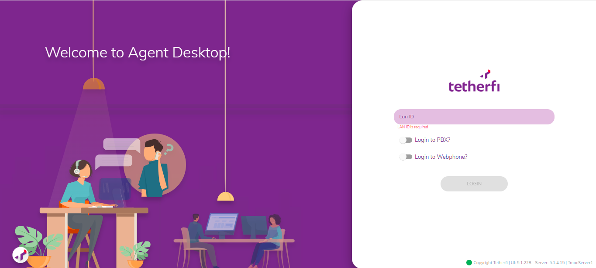

First Page seen by the Agent. Agent can login to the Agent Desktop’s main dashboard from here.

Below are the features that can be seen in this page:

1. Login: This is where user can login with just his lanid / stationid
2. Auto login: This is where the user is auto logged in as soon as AD is loaded. This can be done by providing query parameters to the login path. The following patterns of query parameters are accepted:

* **lanid:** This is used to pass the user’s lanid automatically without filling in the lanid field manually
* **Stationid:** This is used to pass the station id the user wants to log into automatically without filling in the field manually
* **PBX:** This is used to use enable PBX on login and values ‘1’ or ‘true’ can be passed to enable this on login

If User attempts to click the LOGIN button without any credentials placed, an error message will appear stating, “LAN ID Not Provided”

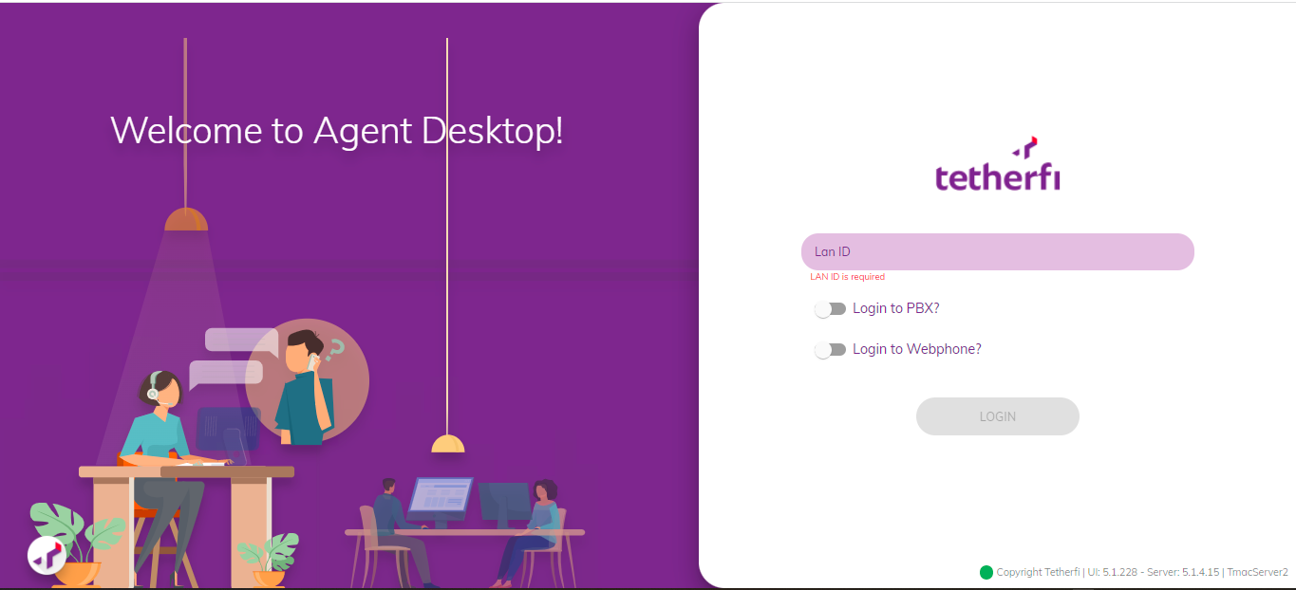

* If user Toggles the “Login to PBX?” or “Login to Web phone” button, User must manually input the station as it’s a Required Field.

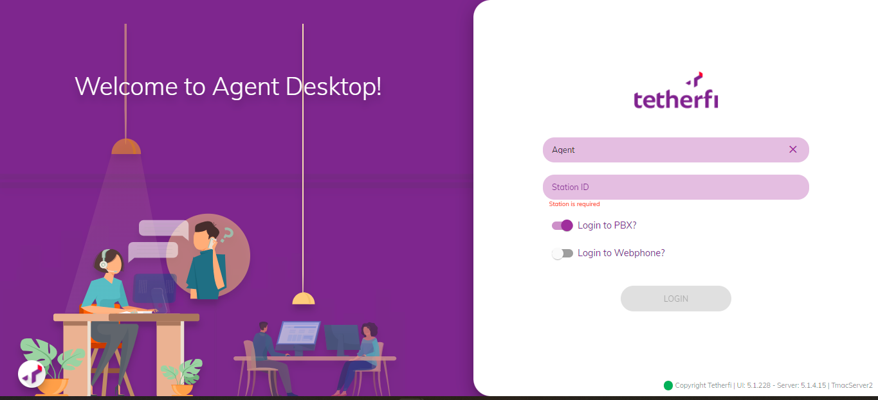

* If the agent is using the Avaya Hard Phone (IP Phone), they can log into Agent Desktop by enabling the "Log into PBX" option and providing their station ID

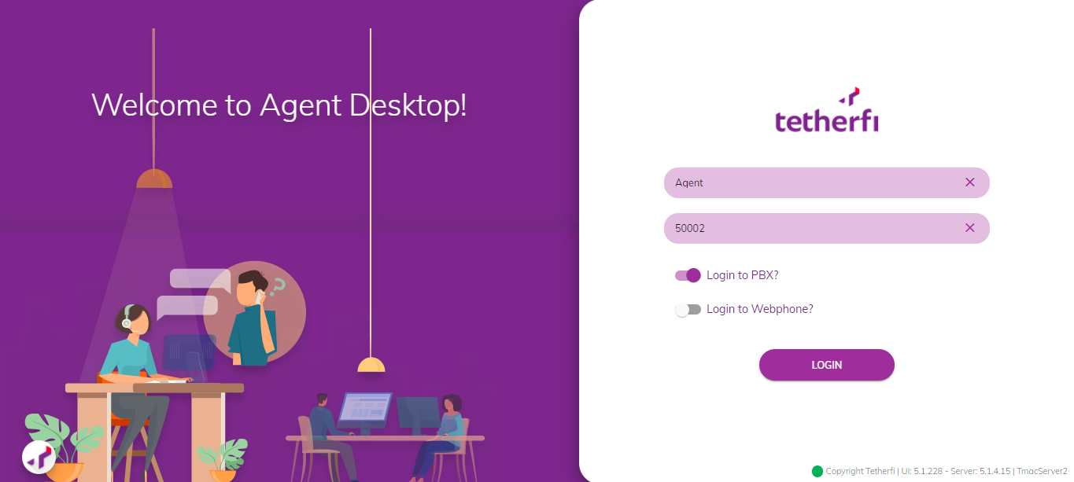

* If the agent is using Web Phone, they can log into Agent Desktop by enabling the "Log into Web Phone" option and providing their station ID.

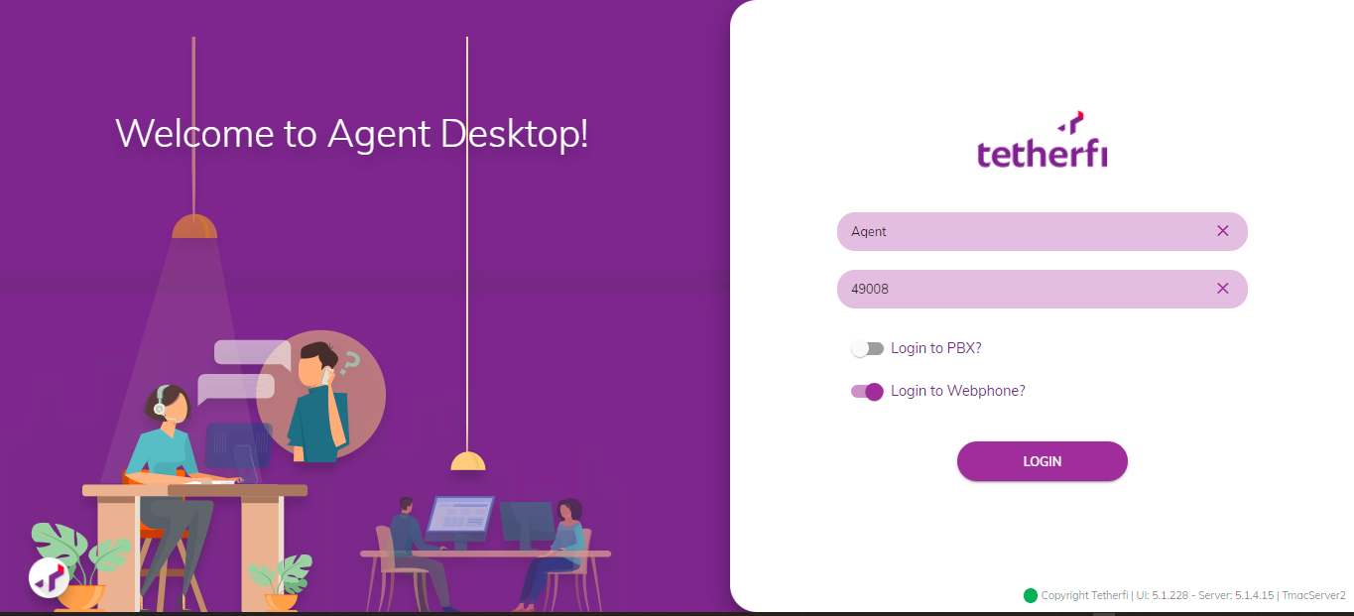

## Home

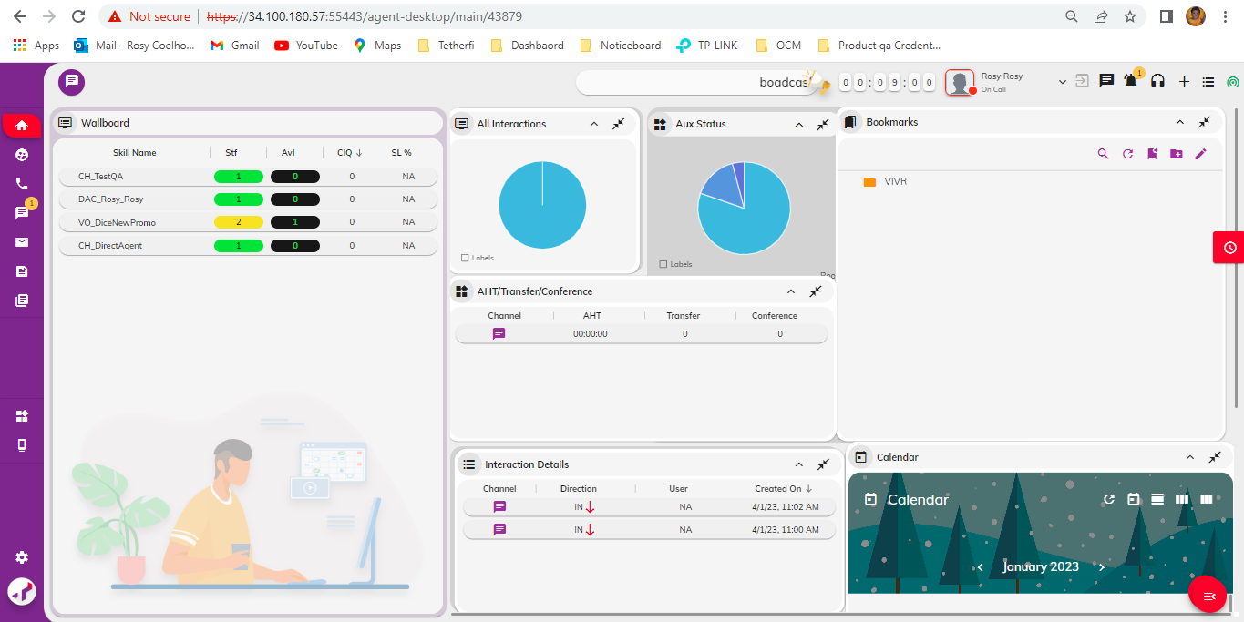

This is a dashboard with the business of AD as a product. This is where the agent spends his time communicating with the customers. Since this is generated dynamically, the content differs from customer to customer

## T-Widgets

This is where all the dynamic widgets of AD are created, configured, and maintained. The widgets are divided into different types and sub-types. The first division of the widgets can be based on the separation of the webpage. They can be shown as below:

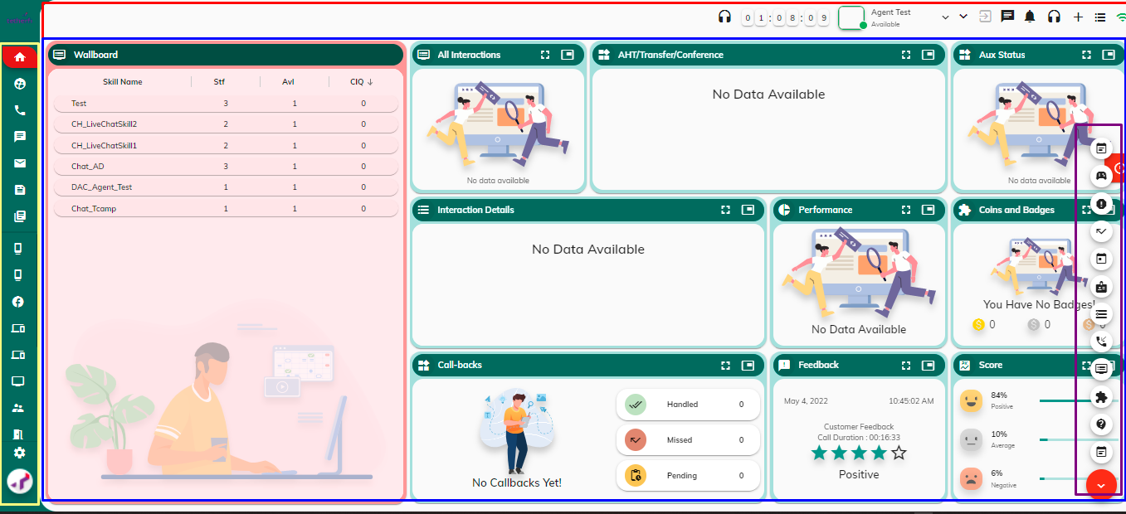

* The Red box shows the **“Toolbar”** widgets.
* The yellow indicates the **“Navbar**” widgets.
* The blue section indicates the **“Content”** widgets.
* The purple box indicates the **“AOT” (Always on top)** widgets.

### **Types of widgets**

As discussed in the T-Widgets section, on a high-level view, the widgets can be divided into Toolbar, Navbar, Content and AOT widgets. In this section, we will see how Navbar, and Content widgets are further divided into different sub-types.

### **Toolbar**

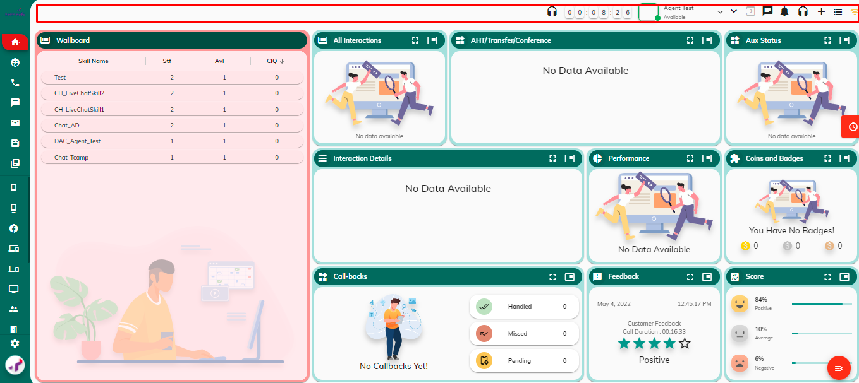

The Red box shows the **“Toolbar”** widgets. Toolbar widget is displayed at the top. There are different options displayed in the toolbar. **Time** is displayed as soon as the Agent has logged in to Agent Desktop in HH:MM:SS **Logged in Agent name** is displayed after the Time. **Aux codes** displayed on click of aux codes.

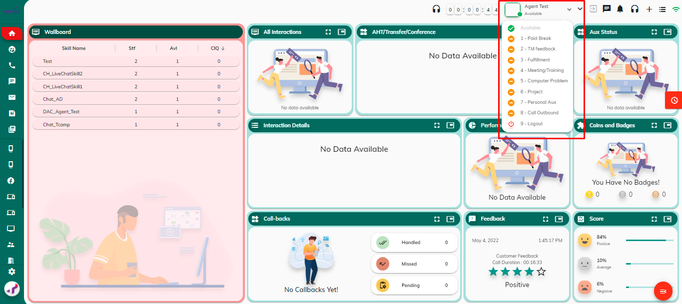

### **Logout Button**

Logout button must be enabled on click of logout in AUX Codes

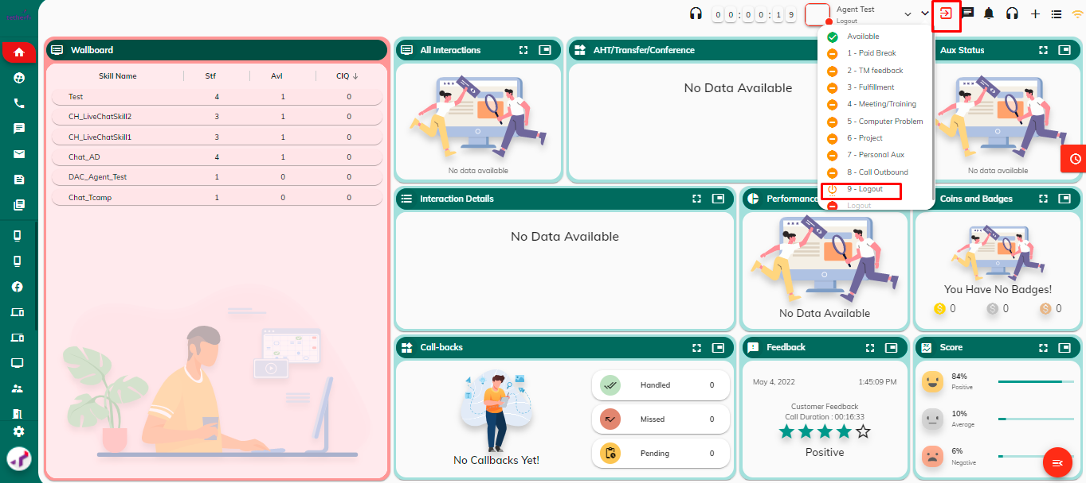

### **Notification**

Notifications is displayed on click of .

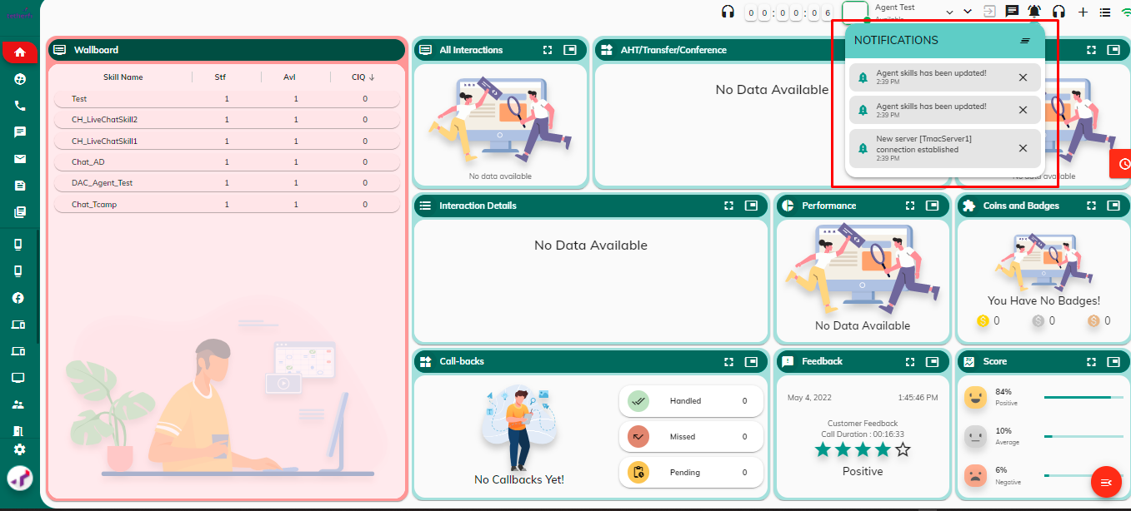

### **Available Devices**

Available Media devices are displayed on click of 

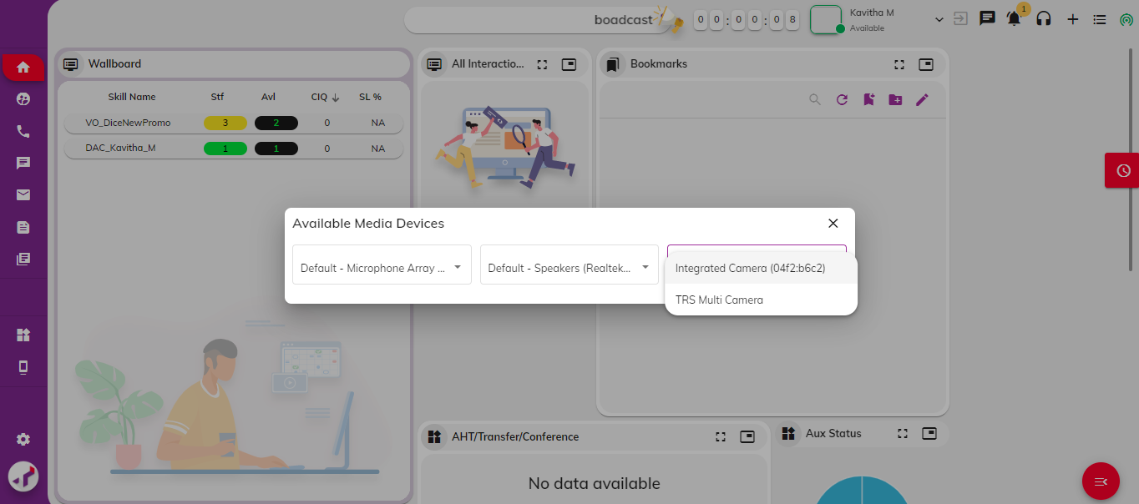

### **More Actions (Make outbound calls)**

On click of 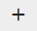 More Actions will be displayed.

* Call Outbound
* Send WhatsApp
* Send Mail

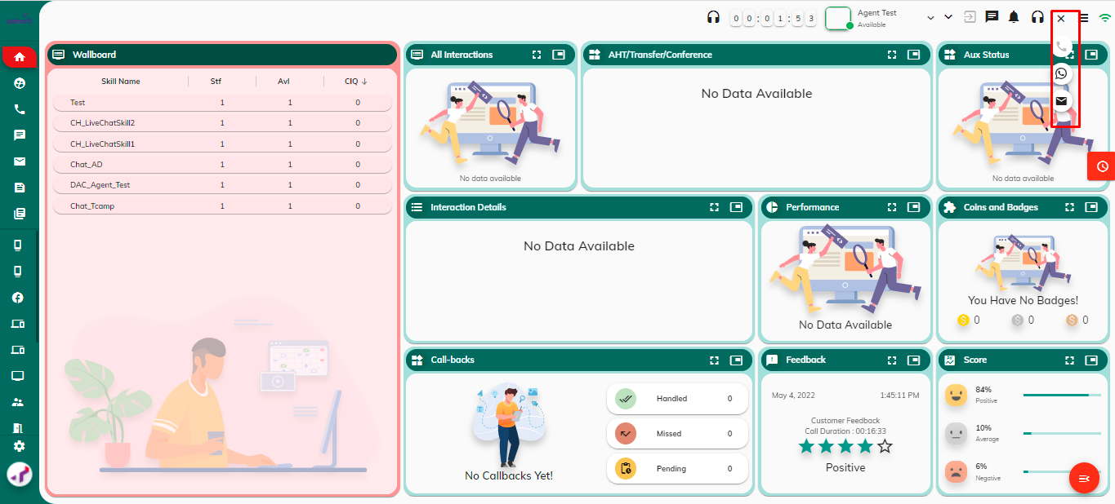

### **View Agent Profile**

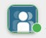Click to view agent profile. You can view the following details:

* Agent Name
* Agent ID
* Role
* Station ID
* Team Name

### **Change Agent Status**

You can change your status by clicking on the 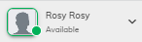status dropdown and choosing a status.

Aux codes are added in OCM in Agent Aux Codes.

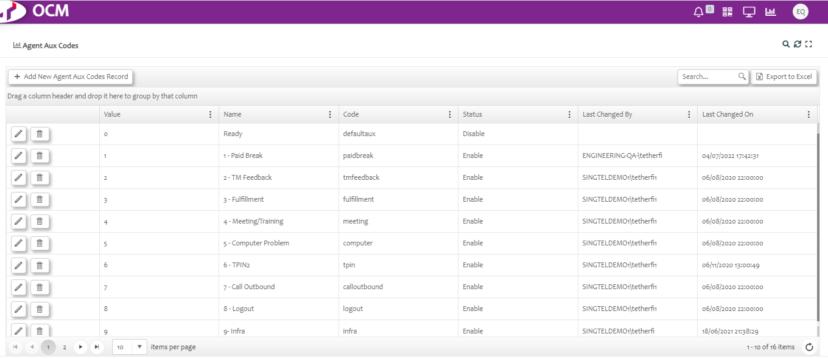

Few Examples of Aux codes are displayed Below:

* Available
* Break
* Meeting/Briefing
* System Problem
* Cover TL
* Call Customer
* Escalation/Support
* Computer Problem
* Logout

ACW (This status is displayed on the drop-down only when you are on **On Call**)

You will be on Default status on successful login. To receive calls, you must change your status to Available

### **App Information**

Application information of different Products which is required in Agent desktop information will be displayed in App Information. The event polling mechanism in CIS is related to the Command Cache, in that it polls the content server on a scheduled interval and if changes are found, it sends out events through the CIS layer. These events tell the Command Cache that content has been updated, a subject has changed, etc., and to clear the cache appropriately. If the event poller is not enabled (via the Event Polling Properties tab on the adapter configuration page), then no events will be generated, and the cached items will only be expired via their timeout values.

Click to view app information such as:

* Agent Desktop Name
* TMAC Server Name
* Event Mode
* Proxy URL
* SignalR URL

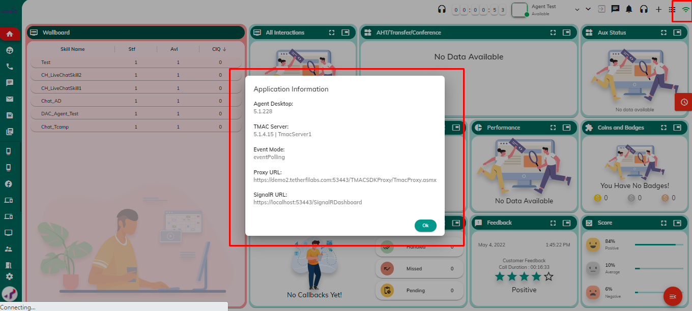

### **Navbar**

The Navbar widgets are divided into the “Top” and “Bottom” widgets. And as the name indicates, the “Top” are displayed on the top section of the Navbar and the Bottom on the Bottom section of the widgets. As shown below, the red box indicates the “Top” part of Navbar widgets, and the blue indicates the “Bottom”

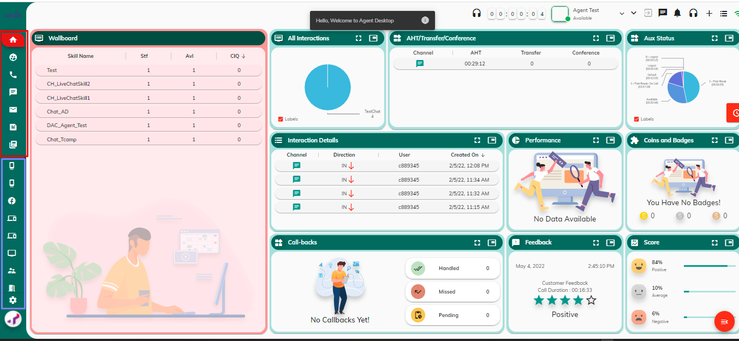

### **Content:**

The Content widgets are further divided into different kinds of subtypes. This will be explained below. But before going into the classifications, it’s important to understand how the widgets are displayed.

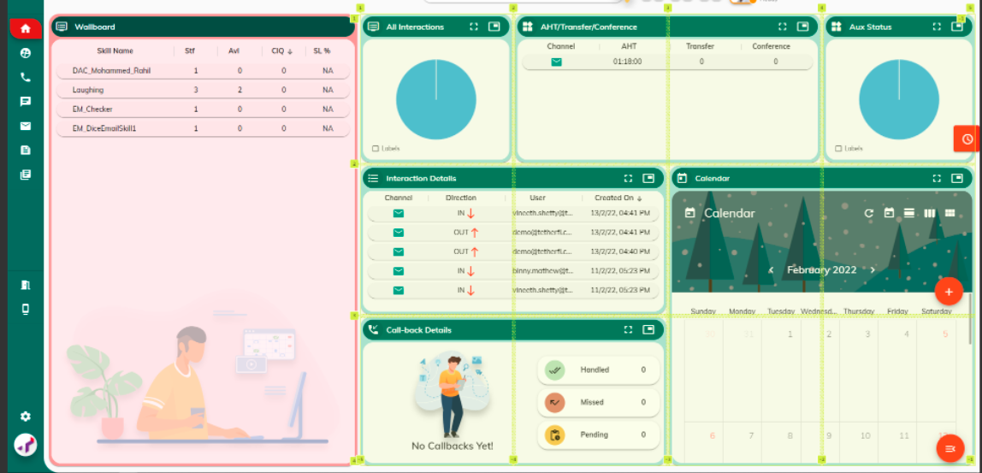

As shown above, AD’s “Content” part is divided into grids. These grids are divided into a total of 6x3 different sections, and the width of each widget is based on this grid dimensions.

**For example:**

1. The Wallboard widget size is 2x3, meaning it consumes 2 grids along the x-axis and 3 grids along the y-axis.
2. The All-Interaction widget size is 1x1, meaning it consumes 1 grid across both the x and y-axes.
3. The Interaction Details widget size is 2x1 meaning it consumes 2 grids along the x-axis and 1 grid along the y-axis.

Now that the widget’s construction size is cleared, we can move on to the classifications of the Widgets.

### Static / Dynamic Widgets:

As show in the above screenshot, the wallboard consumes a larger portion than the other widgets. This is a common pattern seen across the AD dashboard especially widgets that are created during interactions. Below are the few screens to confirm this.

**NOTE**:

* The configurations for dynamic widgets for interaction-related tabs, will be taken from **WidgetConfigData** (if any) sent by TMAC Server on the corresponding interaction-based events.
* These configuration files are located at TMAC_SERVER/widgets/interactions/(interaction_channel).json.

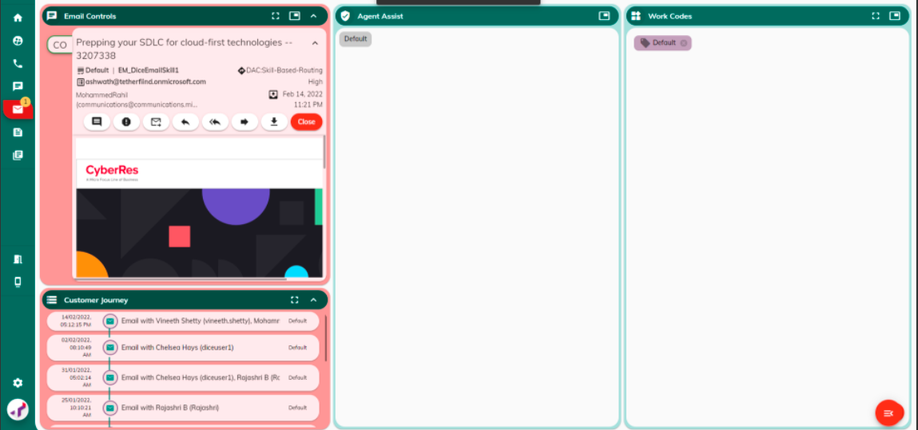

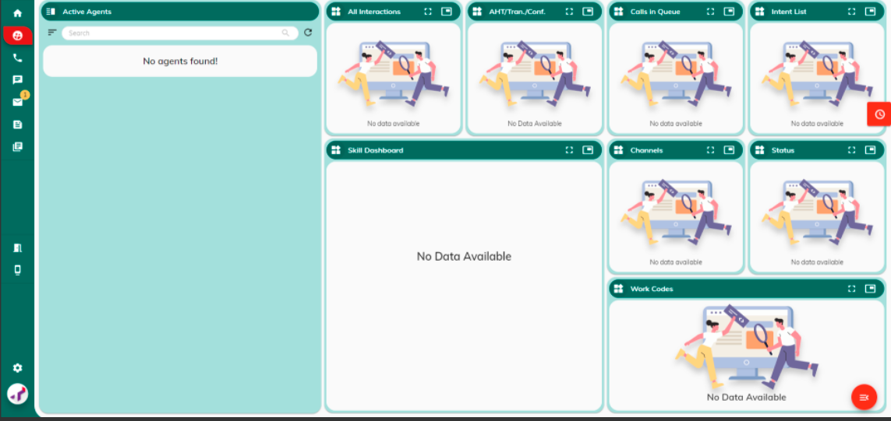

Since this was a common pattern, and during interaction, some of the widgets must be displayed mandatorily, for example in the email interaction above, the “Email Controls” widget is an absolute must, Chat, Voice interactions also have a similar condition. To make this a more generalized pattern across AD, we have Static and Dynamic widgets.

As the name indicates, the Static widgets are displayed by some static configuration, but the Dynamic widgets depends on a dynamic config. How this happens will be covered in the following coding sections. But the simplest difference between these widgets is the size and position.

As seen from the above screens, Static widgets are displayed on the left side with the size 2x3 and the 4x3 size of the screen is left off for the dynamic widgets

### Interaction / Non-Interaction Widgets:

This classification is based on the fact that some of the widgets are constructed especially for the interactions and some aren’t. The non-interaction widgets can usually be used during an interaction, but the interaction specific widgets cannot be used in a non-interaction event or page.

As it may be clear that the interaction widgets are usually displayed during an interaction event i.e., inside the interaction tabs like “Email”, “Chat” and “Voice” and the non-interaction widgets are usually displayed in non-interaction tabs like “Home” and “Workbench”.

### Content / Stand-alone Widgets:

A Content Widget contains a set of Stand-alone widgets. As shown below the red box shows the Content widget “Home” which contains 7 stand-alone widgets marked in blue box.

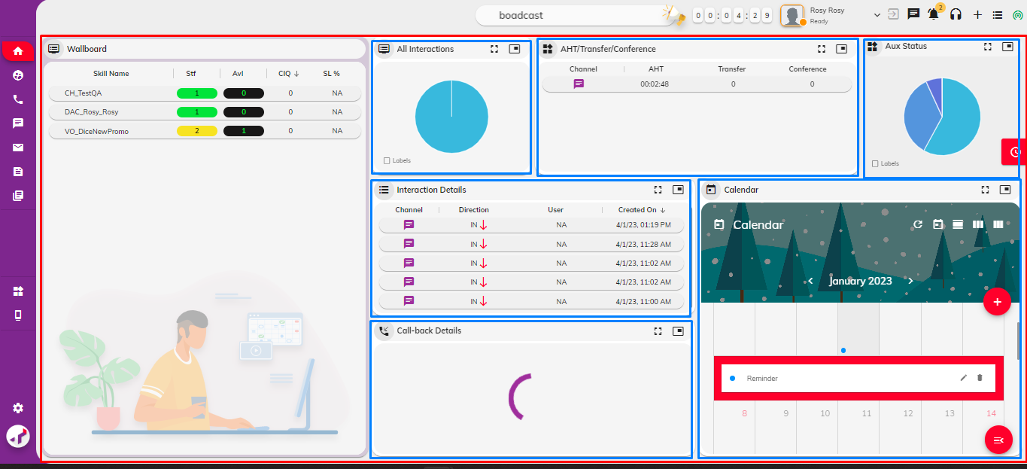

This classification is made to fulfil some prerequisites of some pages for example, an interaction tab may require some setup that is different from a non-interaction page.

## Home

### **Home Page**

This is the landing page that you will see once you login into the TMAC. Multiple widgets are displayed on this page to provide interaction-related data such as:

* Count of all completed Interactions
* AHT/Transfer/Conference count
* AUX Statuses
* Interaction Details

This key information provides valuable insights on your efficiency in handling the customer interactions and helps you to constantly improve your performance to meet the contact-center standards.

A calendar is also displayed on the home page that can be viewed date-wise, week-wise, and month- wise. You can also create **event/task reminders** by clicking the **+** icon on the calendar.

### **All Interactions**

Provides the total number of voice interactions you have completed in the last 100 hrs. This widget is represented as a pie chart, and you can hover over the pie chart to view the interaction count.

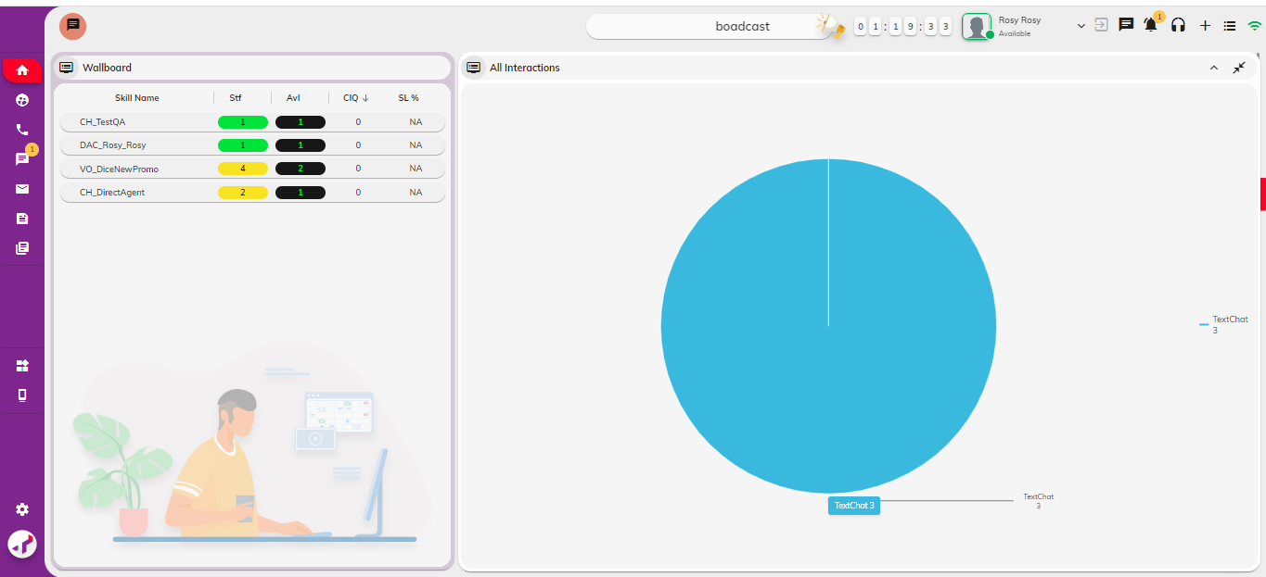

### **AHT/Transfer/Conference**

Displays the following details for voice interactions that you have handled in the last 100 hrs.

* Channel – Medium of communication with the customer.
* Average Handle Time (AHT) – Average time taken to handle a call from start to finish, including hold time, talk time, and post-call processing work. It is calculated as (Talk time + Hold Time + After-call time)/Total number of calls received.
* Transfer – Total count of voice interactions transferred to another agent
* Conference – Total count of voice interactions conferenced in with another agent.

### **AUX Status**

Provides the total time you have spent on different AUX statuses in the last 100 hrs. This widget is represented as a pie chart, and you can hover over the pie chart to view the time spent on a specific AUX status.

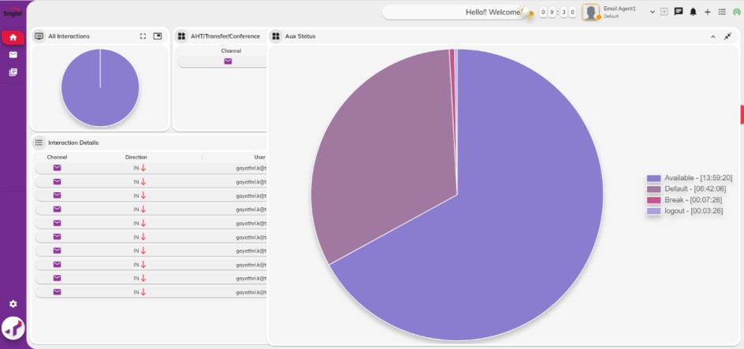

### **Interaction Details**

Displays the following details for email interaction closed in the last 100 hrs.

**Note:** Maximize the widget to view the entire table.

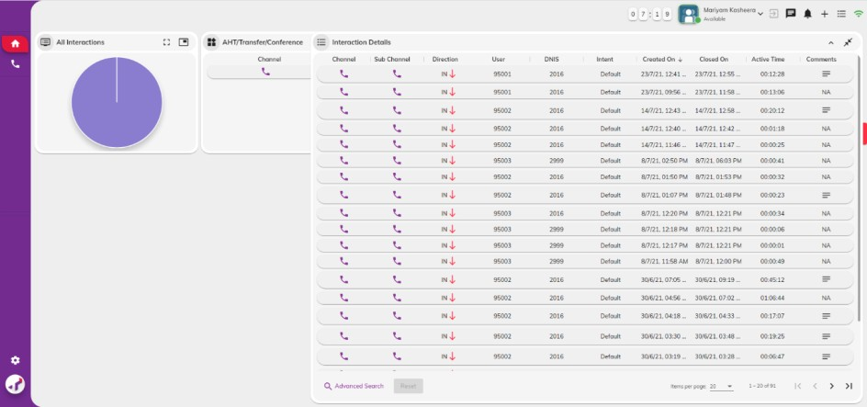

|  |  |
| --- | --- |
| **Field** | **Description** |
| Channel | Medium of communication with the customer |
| Sub-channel | Sub-channel used for communicating with the customer |
| Direction | Indicates whether the call was received by the agent from the customer (inbound) or was made by the agent to the customer (outbound) |
| User | Phone number of the customer. |
| DNIS | Phone number used by the customer to call the contact centre |
| Intent | The reason or the main purpose of the customer call. For example, the intent of customer email can be a broadband issue or a mobile issue. |
| Created Time | The date and time the voice call was received by the agent. |
| Closed Time | The date and time the agent completed his work on the call and closed the voice interaction. |
| Active Time | Total time spent by the agent talking to the customer from start to finish. It does not include hold time, after-call work time. |

### **Viewing Calendar**

You can view the calendar and create various tasks and event reminders related to your work such as follow-up call with the customer, schedule meetings, etc. The active event/task reminders are displayed on the calendar. Use icons displayed on top right corner of the calendar to switch between the day, month, and week views.

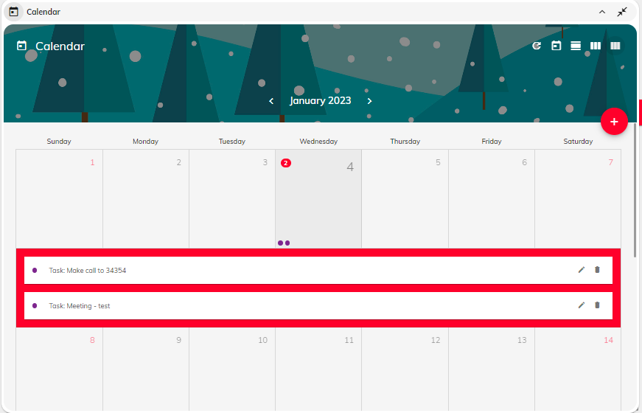

The current date is highlighted with light green background.

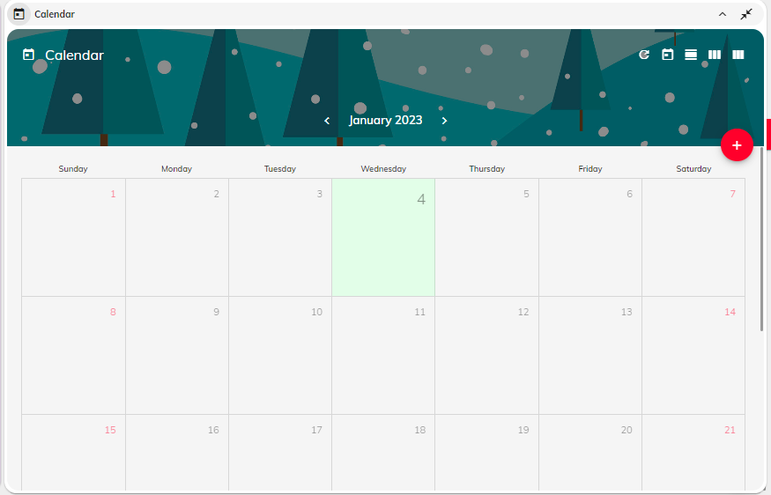

### **Voice Interaction Page**

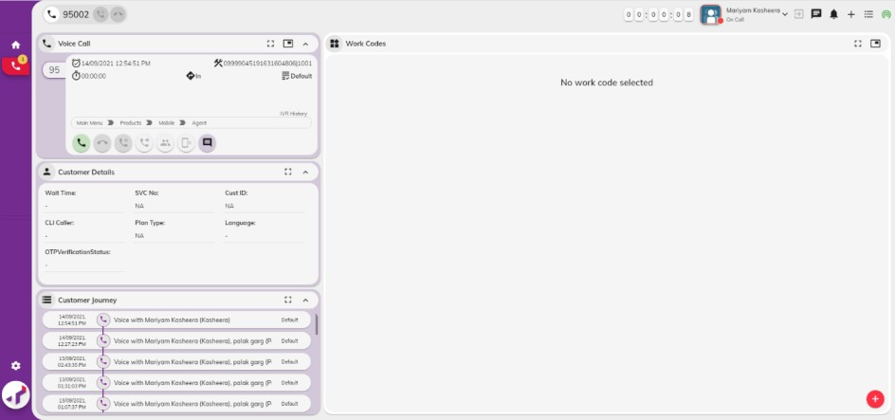On receiving a call, the voice interaction page is displayed, and a notification is seen on the phone icon.

This page provides an intuitive interface to efficiently manage inbound/outbound calls with your customer. The primary widgets on the left panel such as Voice Call, Customer Details, and Customer Journey are fixed unlike other widgets that be floated across the page.

The primary widgets used to handle voice interactions are:

* Voice Call
* Customer Details
* Customer Journey

## SUPERVISOR

This page is available only for the supervisors and provides an overall information of all the agents managed by the supervisor. It provides consolidated view of the following for all the agents in a team.

* Active agents
* Skill Assigned to the agent
* Interaction details
* Calls in Queue
* Time spent on different AUX Codes

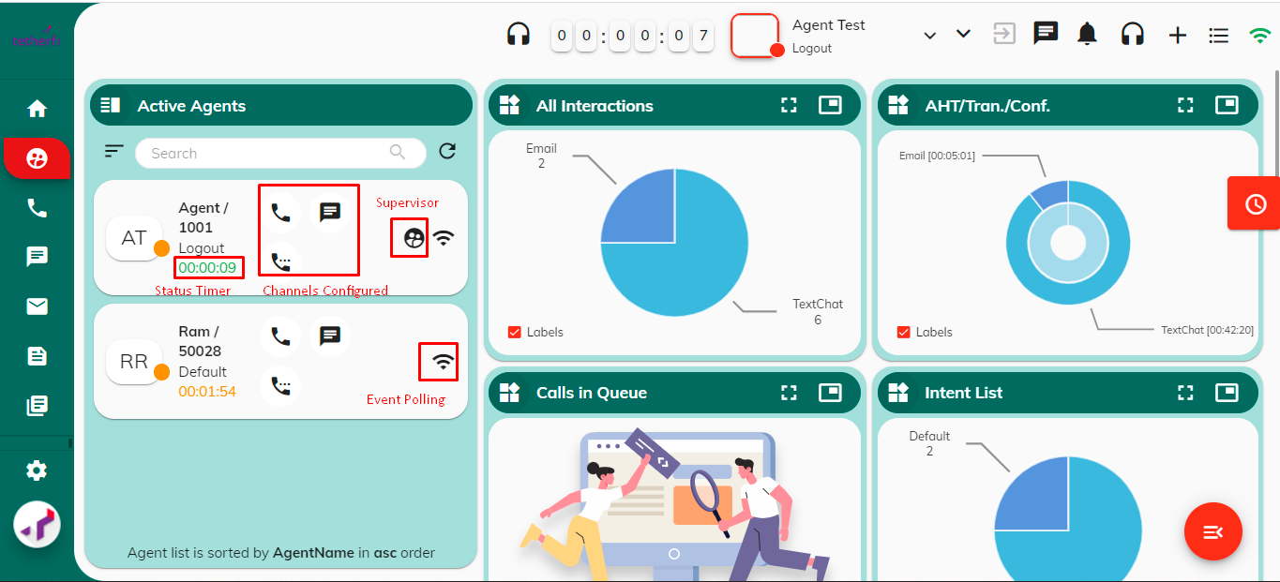

### **Active Agents**

Displays the list of agents currently logged in. The supervisor can view the following details for each agent.

|  |  |
| --- | --- |
| Name/LAN ID | Username/LAN ID of the agent. |
| Current Status | The current agent status. |
| Status Duration | Time elapsed since the agent moved to the current status. |
| Channel Availability/Count | The different channels and the count of each channel available for customer interaction. |
| Active channel count | Total interactions currently engaged on a channel. |
| Supervisor indicator | Indicates whether the agent has supervisory role. |

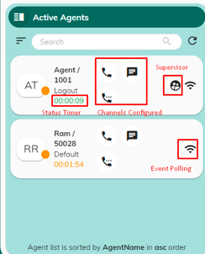

This widget enables the supervisor to view the agent’s interactions and monitor/coach the agent if required. The supervisor can also force log out the agent.

As a supervisor, you can perform the following tasks using AD:

* View real-time performance statistics of your agents.

Click 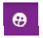 on the side bar. The supervisor page is displayed.

* View active interaction details of an agent.

From the Active Agents widget, select the agent to change the status.

* Monitor agent’s interaction.

Click 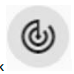 and select the status to change from the drop-down.

* Barge-in on agent’s voice interaction.
* Change the agent’s state.
* Force log-out an agent.

You can also force log out an agent if you discover that an agent has forgotten to log out after their shift. This feature is useful because it prevents interactions from being routed to an agent who is not present but is configured for auto-answer.

Note: You cannot log out an agent while they are handling an interaction.

* Coach the agent work.

### **Viewing Interactions**

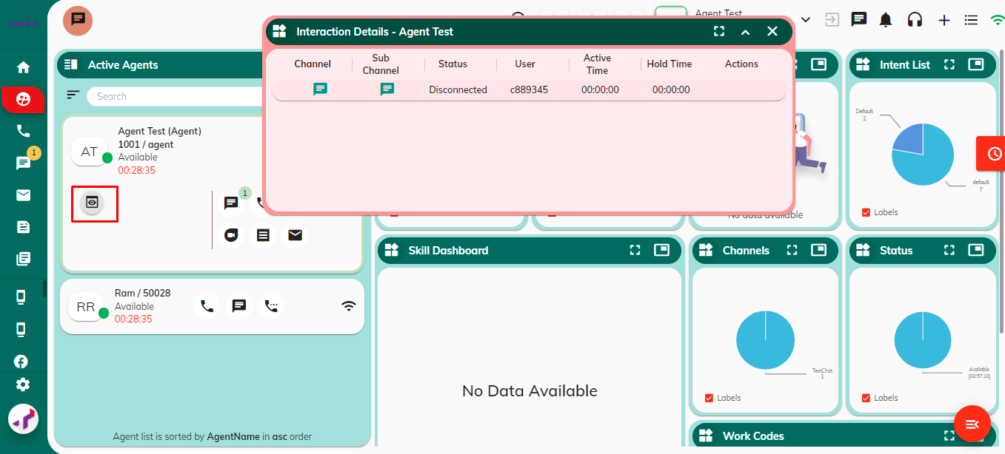

You can view the ongoing interactions of any agent in your team. To view the agent’s interactions, do the following

* Click 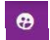 on the side bar. The supervisor page is displayed.
* From the Active Agents widget, select the agent you want to view the interactions.
* Click  You can view the current ongoing interaction of an agent.

### **Viewing Metrics**

AD enables the supervisor to gain a holistic view on how the team is performing and view important metrics such as total number of interactions/channels being handled, total number of agents assigned to a skill, total calls currently waiting in the queue, etc. These real-time metrics provide valuable insights on how efficient and effective the agents are in handing the customer interactions. It enables the supervisor to quickly recognize any problematic situation and take actions accordingly.

For example, if the supervisor identifies that the total number of calls in service queue with a specific intent is exceeding a threshold value, then the supervisor can allocate additional agents with the specific skill to handle more customer calls. Multiple widgets are used to display the metrics on the supervisor page.

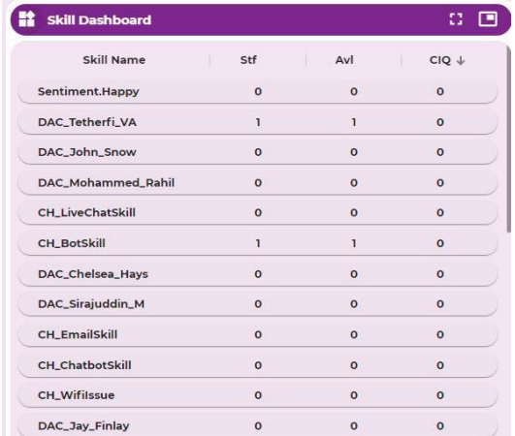

The skills dashboard Provides real-time information to the supervisor on the number of calls available in the queue against a specific skill, the skills assigned to all the agents and the total number of staffed and available agents for each skill. The information in the wallboard is refreshed every few seconds which can be configured via OCM.

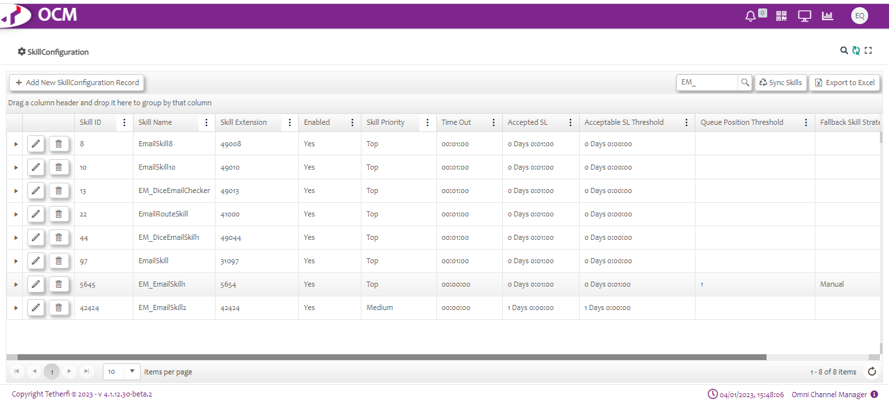

The skill with the highest number of CIQ appears on the top. This widget enables the supervisor to constantly monitor the total number of calls in the queue and take actions to reduce customer wait time to decrease customer dissatisfaction and call abandonment. For example, if there are 20 calls in CIQ for a specific skill and there are no available agents to answer the calls then the supervisor can assign more agents to a specific skill to reduce the calls in the queue.

|  |  |
| --- | --- |
| **Field** | **Description** |
| Skill Name | Name of the skill |
| Staffed Agents (Stf) | Total number of logged in agents currently working (On Call) on a specific skill. |
| Available Agents (Avl) | Total number of logged in agents currently available to work on a specific skill. |
| Calls in Queue (CIQ) | Total number of calls in queue for a specific skill. |

### **Viewing Calls In-Queue**

A pie chart that represents the total number of Calls in Queue (CIQ) for all skills. This widget helps the supervisor to constantly monitor the total number of calls waiting to be answered at any given time. If the CIQ exceeds a threshold value, then the supervisor can immediately allocate additional agents to handle the customer calls.

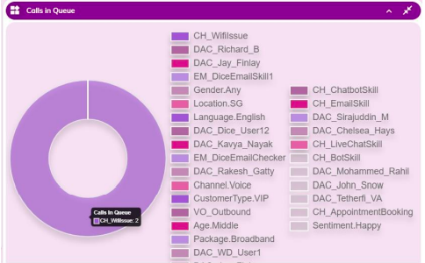

### **Viewing Intent List**

A pie chart that represents the customer intent count for all interactions in the last 100hrs for all the agents in the team. This widget enables the supervisor to quickly identify the common issues faced by customers.

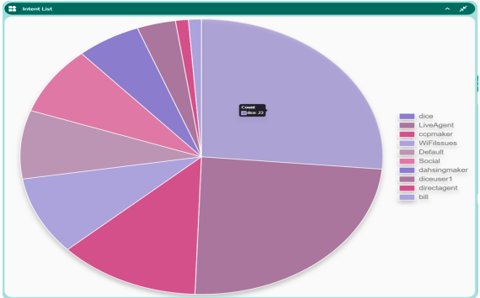

### **Channels**

A pie chart that represents the total. This widget enables the supervisor to understand which channels the customers prefer the most to reach the contact center. Note: Hover your mouse over the pie chart to view the ongoing channel counts.

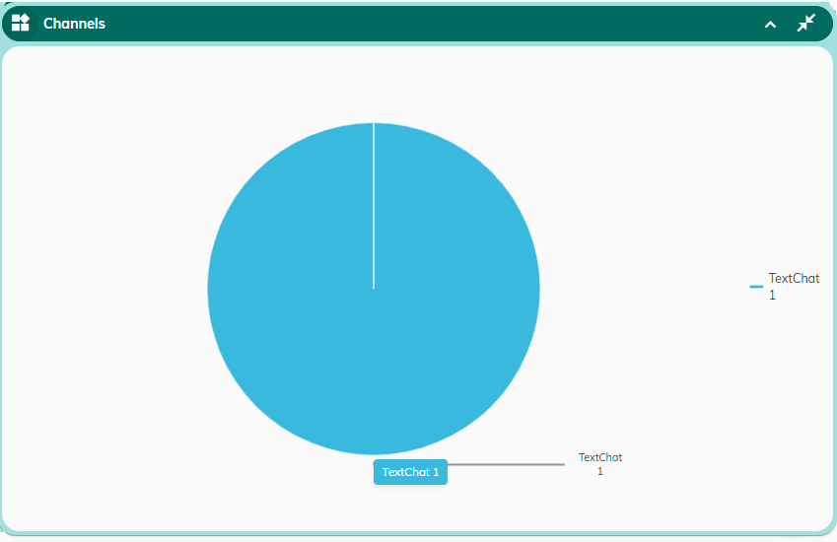

### **Work Codes**

Work codes provide a way to track the different reasons your customers are calling-in. The supervisor can set the different reasons to account for and at the end of each interaction a specific work code can be tagged to the customer call. This widget displays the wrap-up code summary, and it indicates the number of times a specific work code was tagged to an interaction.

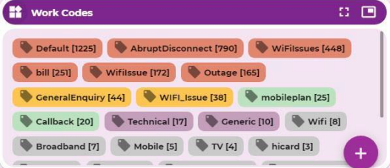

### **Status**

Duration of each AUX status. This key information provides valuable insights on your efficiency in handling the customer interactions and can help you to constantly improve your performance to meet the contact-centre standards.

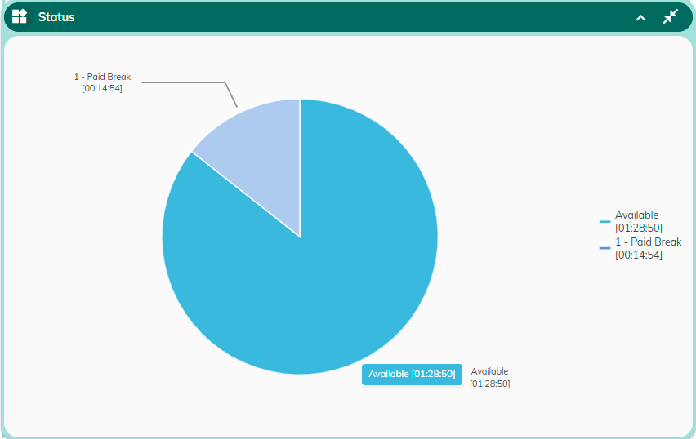

## Voice Interactions

This widget is primarily used to handle phone calls with your customer. It supports a tabbed interface to handle multiple calls simultaneously. On accepting a call with your customer, the following details are displayed on top of the window.

* Interaction start time
* Interaction timer
* Session ID/Interaction ID
* Direction (Inbound/Outbound)
* Intent
* IVR path for incoming calls via IVR

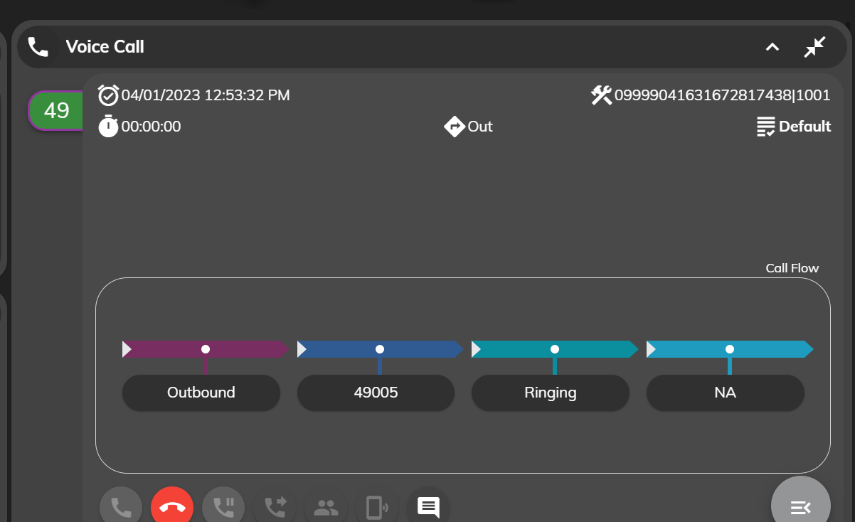

The voice interaction controls available in this widget are listed below:

|  |  |
| --- | --- |
| **Interaction**  **Control** | **Purpose** |
|  | Click this button to answer the call |
|  | Click this button disconnect the call |
|  | Click this button to put the caller on hold. To resume the call, click the button again. |
|  | Click this button to transfer the call to another agent. |
|  | Click this button to conference in with another agent |
|  | Click this button to enter interaction notes |

### **View Customer Details**

This widget displays the customer details currently interacting with the agent. The customer details are configured based on user requirements.

The following displayed customer details is the example on the user requirement:

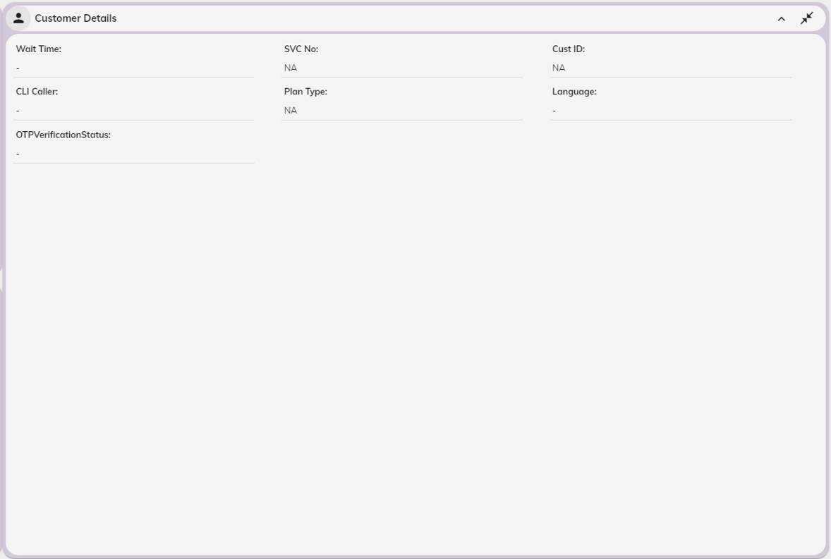

|  |  |
| --- | --- |
| **Field** | **Description** |
| Wait Time | The amount of time the customer waited in a queue before being answered by the agent. |
| SVC No. | The service number of the customer |
| Cust ID | Customer identification number. Service can also be used as an  identification number. |
| CLI Caller | Caller ID or the phone number that the customer used to call the  contact center. |
| Plan Type | Customer plan type. |
| Language | The language chosen by the customer for interaction with the  agent via IVR. |
| OTPVerificationStatus |  |

### **View Interaction Details**

This widget displays all the past interactions the customer has had with the contact center. This widget enables you to view the entire customer journey and gain an understanding of all actions taken by the agent(s). This enables you to understand the customer and his problem better and provide a satisfactory response.

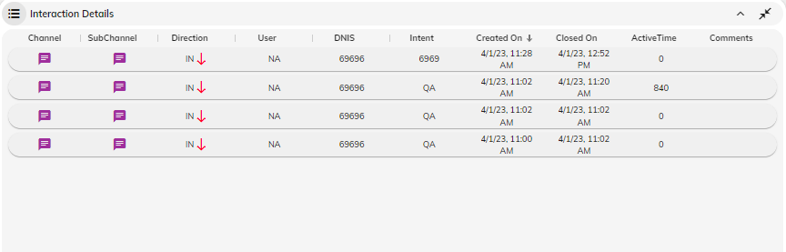

The following details are displayed in this widget:

|  |  |
| --- | --- |
| **Field** | **Description** |
| Created On | The date and time the agent received the customer call. It is represented as DD/MM/YY HH : MM(AM/PM) |
| Closed On | The date and time the agent disconnected the customer call. It is represented as DD/MM/YY HH : MM  (AM/PM) |
| Channel | The channel used by the customer for reaching the contact center. It  can be voice/email or chat. |
| Intent | The purpose of the customer call. |
| User | Name of the User |
| Active Time | Active time between customer and Agent |
| Comments | Comments related to the call by Agent |

You can click the ellipsis (three dots) displayed on the right to view the following information for each interaction.

#### Interaction Actions

Click on Customer Journey to view the sequence of actions the agent has taken from the time and the details of interactions between customer and Agent.

Each session Actions entry includes additional metadata information such as:

* Date and time the action was executed.
* Channel
* Direction
* Interaction Text
* Intent
* Service Agents
* CIF
* NRIC
* Phone Number
* Email
* Sentiment
* Interactions
* Session History
* Actions
* Comments
* Transcripts

Click **View Data** to view the following details:

|  |  |
| --- | --- |
| **Field** | **Description** |
| Received At | Date and time the action was executed |
| Channel | The channel of communication |
| Direction | Incoming or Outgoing interactions |
| Interaction Text | The type of action executed. For example, the type of actions can include IncomingCall, AnswerCall,  OnConnected, ConferenceCall, OnCallHold, etc. |
| Data | Additional metadata regarding the specific action  such as Intent, Service Agents, CIF ,NRIC,Phone Number ,Email, Sentiment, Interactions ,Session History ,Actions ,Comments and Transcripts . |

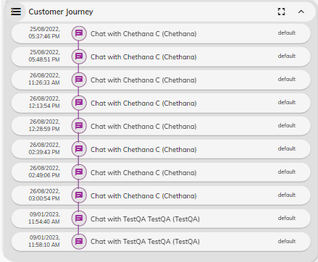

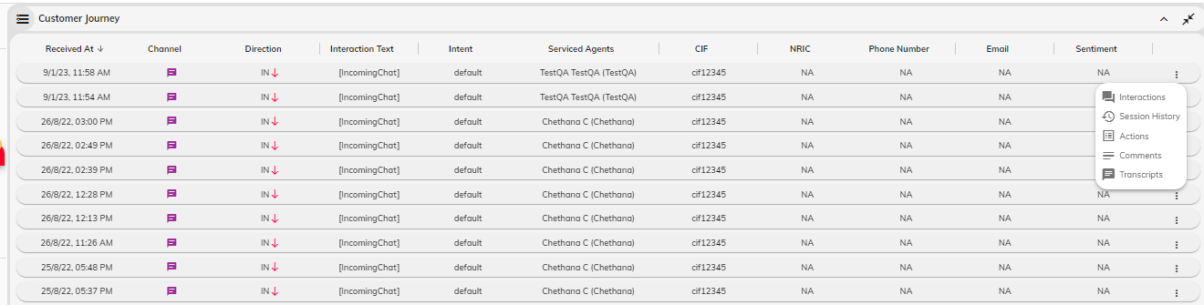

#### Actions

Click Action to view the history of all actions taken by an agent for a voice interaction such an Incoming Call, Answer Call, On Call Hold, Conference Call, On Conference Initiated, On Conference Remote Connected, Conference Complete, etc.

#### Comments

Click Comments to view the history of all the interaction comments entered by agent(s) for a voice interaction

### **Handling Voice Calls**

TMAC Agent Desktop can be used to handle the following voice tasks:

* Accepting a call
* Holding/Retrieving a call
* Initiating a conference call
* Transferring a call to another agent
* Wrapping up after a call

#### Accepting a call

You will receive a call on your agent desktop in the following cases:

* Call from the customer
* Call from another agent
* Transferred call from another agent
* Conference call

When you receive a call on your agent desktop, a ringing tone is heard on your headset and the customer name/phone number is displayed on the desktop.

**Before you Begin**

* Ensure your status is set to **Available**.
* Ensure that you are assigned to a skillset for handling voice calls.

To accept an incoming call, do the following:

1. Click 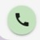 to accept the call. On accepting the call, your status is automatically changed to

**OnCall** and the call timer is started.

1. Once you accept the call, you can maximize and view the customer details in the **Customer Details** widget. You can also view detailed information on all the past interactions that the customer has had with the customer in the **Customer Journey** widget.
2. As you talk to your customer, you can enter your comments. If you are unable to provide a satisfactory response, you can either transfer your call to an agent/pool of agents or initiate a conference call with another agent.
3. If you are unable to provide a satisfactory response, you can either transfer your call to an agent/pool of agents or initiate a conference call with another agent.
4. Once the call is over, click 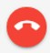 to disconnect the call and complete your post-call processing work.

**Note:** While answering the call, you can view the customer details on the **Customer Details**widget and the past interactions that the customer has had with the contact center in the **Customer Journey** widget.

#### Entering Interaction Comments

You can enter meaningful interaction comments as you interact with your customer. These interaction comments are stored as part of the customer journey and can be useful in multiple ways such as: While transferring/initiating a conference call, the new agent can view your comments and quickly understand the customer's problem and respond suitably. In scenarios, where the customer contacts the contact center multiple times on the same issue, the new agent can view the history of interaction comments in the customer journey widget and understand the past actions taken on the customer issue.

Click  to enter interaction comments.

#### Holding/Retrieving a Call

To place an active call temporarily on hold, do the following:

1. Click  to hold the active call.

To retrieve the call from hold and continue the conversion, click the same hold button.

#### Transferring a Call

During a conversation with the customer, you can transfer the call to another agent. For example, if agent A receives a call from the customer and the agent is unable to respond to the customer query satisfactorily then agent A can transfer the call to another agent who can respond to the customer query.

TMAC supports two kinds of transfer.

##### **Blind Transfer**

A blind transfer is when you transfer the call to a pool of agents or another agent without speaking to the new agent first. For example, if a customer reaches the sales department via IVR for his billing query, then the sales customer agent can transfer the customer to a pool of agents handling the account billing. In this type of transfer, you do not have to wait until the new agent is connected to the call.

Note: If the new agent does not accept the call within a stipulated time, then the call is transferred to the queue.

To initiate a **blind transfer**, do the following:

* Click 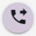. The transfer call pop-up window is displayed.
* For **agent-based** transfer,
* The **Agent List** displays a list of all agents in the team along with their ID and current status.
* Click the agent to transfer the call.
* **Note:** You can transfer the call only to **AVAILABLE** agents
* Enter your transfer comments to provide the reason for the transfer and any other specific information on the customer query.
* Click 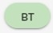. The new agent receives the call and on accepting the call the new agent can talk to the customer.
* You can now disconnect your call.
* For **skill-based** transfer,
* Choose **Skill List**. A list of skills configured in the system is displayed along with the count of total agents staffed and are available for that skill set.
* **Note:** Ensure that you transfer the call to a skill set with at least 1 available agent.
* Click the skill to transfer the call
* Enter your transfer comments to provide the reason for the transfer and any other specific information on the customer query.
* Click . The new agent receives the call and on accepting the call the new agent can talk to the customer.
* You can now disconnect your call

##### **Consultation Transfer**

A consultation transfer is when you can put the caller on hold and speak to the new agent before the call is transferred. You can provide any background information regarding the caller’s issue to the new agent before transferring the call. The call is transferred successfully only after both the agents confirm the transfer.

To initiate a consultation transfer, do the following:

* Click .

For **agent-based** transfer,

* The **Agent List** displays a list of all agents in the team along with their ID and their current status.
* Click the agent to transfer the call.
* **Note:** You can transfer the call only to **AVAILABLE** agents
* Enter your transfer comments to provide the reason for the transfer and any other specific information on the customer query.
* Click 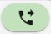. The consultation transfer is initiated.
* On successful transfer initiation, the new agent receives the call, and the customer is put on hold.
* When the new agent **accepts** the call, you can have a conversation with the new agent and provide any specific information on the customer query.

**Note:** You can cancel the transfer at any time. For example, if the new agent does not accept the call within the stipulated time, then you can click **Cancel** and continue talking to the customer.

* After discussion, when the new agent is ready to answer the customer, you can click
* **CONFIRM** and the call is successfully transferred to the new agent.
* You can disconnect the call now.

For **skill-based** transfer,

* Choose **Skill List**. A list of skills configured in the system is displayed along with the count of total agents staffed and are available for that skill set.
* Click the skill to transfer the call.

**Note:** Ensure that you transfer the call to the skillset with at least 1 available agent.

Enter your transfer comments to provide the reason for the transfer and any other specific information on the customer query.

* Click . The consultation transfer is initiated.
* On successful transfer initiation, the first AVAILABLE agent in the skill set receives the call and the customer is put on hold.
* When the new agent **accepts** the call, you can have a conversation with the new agent and provide any specific information on the customer query.

**Note**: You can cancel the transfer at any time. For example, if the new agent does not accept the call within a stipulated time, then you can click **Cancel** and continue talking to the customer.

* After discussion, when the new agent is ready to answer the customer, you can click
* **CONFIRM** and the call is successfully transferred to the new agent.
* You can disconnect the call now.

#### Initiating a Conference Call

A conference is a call where three or more parties can talk to each other simultaneously. You can initiate a conference call with another agent while in conversation with your customer.

TMAC supports two kinds of conference call:

##### **Blind Conference**

A blind conference is when you initiate a conference call to a pool of agents based on the skill set or another agent without speaking to the new agent first.

To initiate a **blind conference**, do the following:

* Click 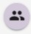. The conference call pop-up window is displayed.

For **agent-based** conference,

* The **Agent List** displays a list of all agents in the team along with their ID and current status.
* Click the agent to conference with.
* **Note:** You can initiate conference call only with **AVAILABLE** agents
* Enter your comments. You can specify the reason for initiating the conference call or provide any specific information on the customer query.
* Click 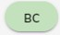. A conference call is initiated.
* The new agent receives the call and on accepting the call. A conference call is established between you, the new agent, and the customer.

For **skill-based** conference,

* Choose **Skill List**. A list of skills configured in the system is displayed along with the count of total agents staffed and are available for that skill set.
* Click the skill to initiate a conference call.
  + 1. **Note:** Ensure that you initiate a conference call with at least 1 available agent in the skill set.
       - 1. Enter your comments. You can specify the reason for initiating the conference call or provide any specific information on the customer query.
         2. Click . A conference call is initiated.
         3. The first available agent in the skill set receives the call. On accepting the call. A conference call is established between you, the new agent, and the customer.

##### **Consultation Conference**

A consultation conference is when you can put the caller on hold and speak to the new agent before creating a conference call. You can provide any background information regarding the caller’s issue to the new agent before initiating the conference call. A conference call is successfully created only after both the agents confirm the conference.

To initiate a consultation conference, do the following:

* Click 

For **agent-based** conference,

* The **Agent List** displays a list of all agents in the team along with their ID and their current status.
* Click the agent to conference with.
* **Note:** You can initiate a conference call only with **AVAILABLE** agents
* Enter your comments. You can specify the reason for initiating the conference call or provide any specific information on the customer query.
* Click 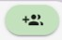. The consultation conference is initiated.
* On successful conference initiation, the new agent receives the call and the customer is put on hold.
* When the new agent **accepts** the call, you can have a conversation with the new agent and provide any specific information on the customer query.
* **Note:** You can cancel the conference call at any time. For example, if the new agent does not accept the call within a stipulated time, then you can click **Cancel** to cancel the conference and continue talking to the customer.
* After discussion, when the new agent is ready to answer the customer, you can click **CONFIRM** and a conference call is established successfully between you, the new agent, and the customer.

For **skill-based** transfer,

* Choose **Skill List**. A list of skills configured in the system is displayed along with the count of total agents staffed and are available for that skill set.

**Note:** Ensure that you initiate a conference call with at least 1 available agent in the skill set.

* + - * 1. Click the skill to initiate a conference call.
        2. Enter your comments. You can specify the reason for initiating the conference call or provide any specific information on the customer query.
        3. Click . A conference call is initiated.
        4. On successful conference initiation, the first AVAILABLE agent in the skill set receives the call and the customer is put on hold.
        5. When the new agent **accepts** the call, you can have a conversation with the new agent and provide any specific information on the customer query.

**Note:** You can cancel the conference call at any time. For example, if the new agent does not accept the call within a stipulated time, then you can click **Cancel** to cancel the conference and continue talking to the customer.

After discussion, when the new agent is ready to answer the customer, you can click **CONFIRM** and a conference call is established successfully between you, new agent, and the customer.

#### Tagging a Work Code

You can tag one or more relevant work codes once you complete your interaction with the customer.

To tag a work code, do the following:

* Click **+** in the Work Codes widget. The Select Work Codes window is displayed.
* Select work code from the Work Code list. Press Enter
* The work code(s) is tagged to the interaction.

#### Wrapping up after the Call

On completing your interaction with the customer, you can change your status from **On Call** to **ACW** (After Call Work). You can use the time in this state to complete any post-call processing work. You will not receive any calls while you are on **ACW**.

To wrap up after the call, do the following:

* Once the interaction is completed, before disconnecting, choose **ACW** from the status drop- down.
* **Note:** The status does not change from **On Call** to **ACW** immediately, it remains on **On Call** until you disconnect.
* Click . The call gets disconnected, and the status is changed to ACW.
* Complete any post-call processing work. Tag a relevant work code for your interaction.
* Click **Close**. The interaction tab is closed.
* Change your status to **Available** to accept a new call or make yourself temporarily unavailable by setting your status to a suitable AUX Code.

## Chat Channel

This page provides an intuitive interface to efficiently manage chats with your customer. The primary widgets on the left panel such as Voice Call, Customer Details, and Customer Journey are fixed unlike other widgets that be floated across the page.

* Chat controls
* Customer Details
* Interaction History
* Agent Assist
* Canned Response
* Work codes

### **Chat controls**

The image depicted below represents the view of the Agent when the Agent is in Available state and the chat comes through.

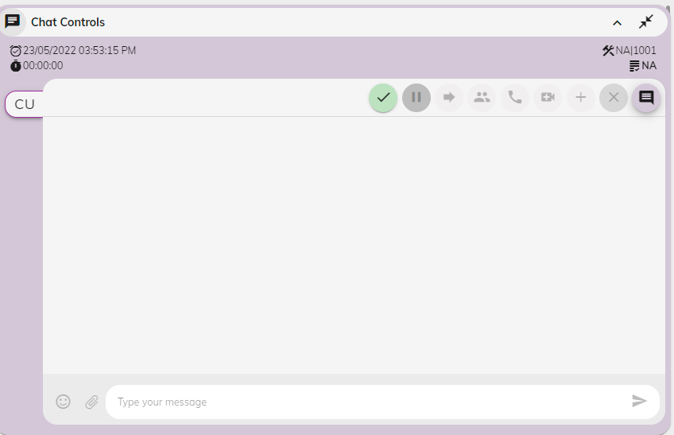

The chat interaction controls available in this widget are listed below:

|  |  |
| --- | --- |
| **Controls** | **Description** |
|  | Click this button to answer the chat |
|  | Click this button end the chat |
|  | Click this button to put the chat on hold. To resume the call, click the button again. |
|  | Click this button to transfer the chat to another agent. |
|  | Click this button for conference in another agent |
|  | Click this button to Escalate to Audio |
|  | Click on this button to Escalate to Video |
|  | Click on this button to More Actions |
|  | Click on this button to add interaction comments |

Click this button to put the chat on hold. To resume the call, click the button again.

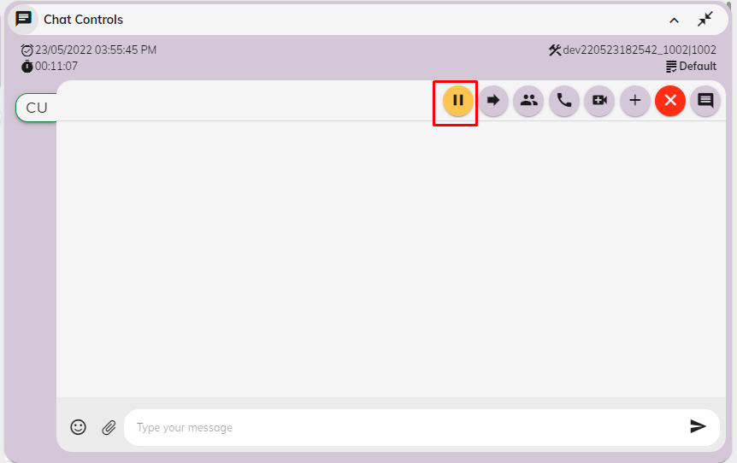

To resume the chat click on unhold button

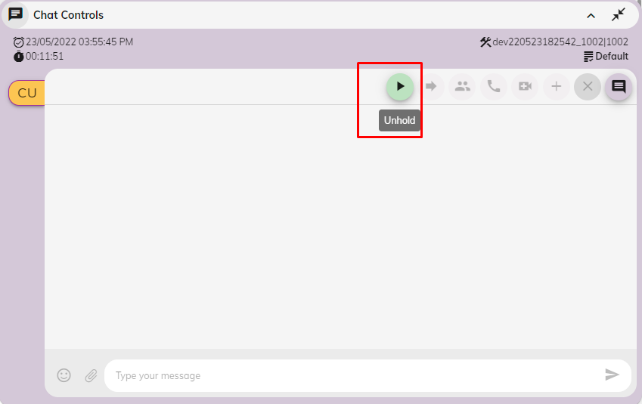

### **Transfer the chat**

During a conversation with the customer, you can transfer the call to another agent or skill list

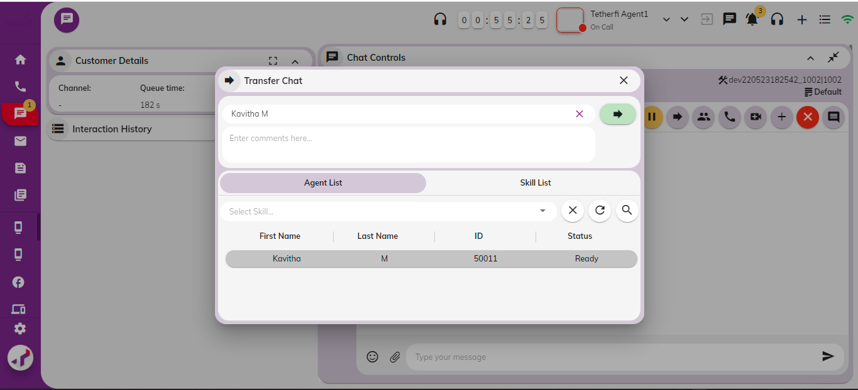

### **Conference the chat**

A conference is a chat where three or more parties can talk to each other simultaneously. To create a conference chat with a customer and another agent, do the following

Choose the agent you want to conference with Agent

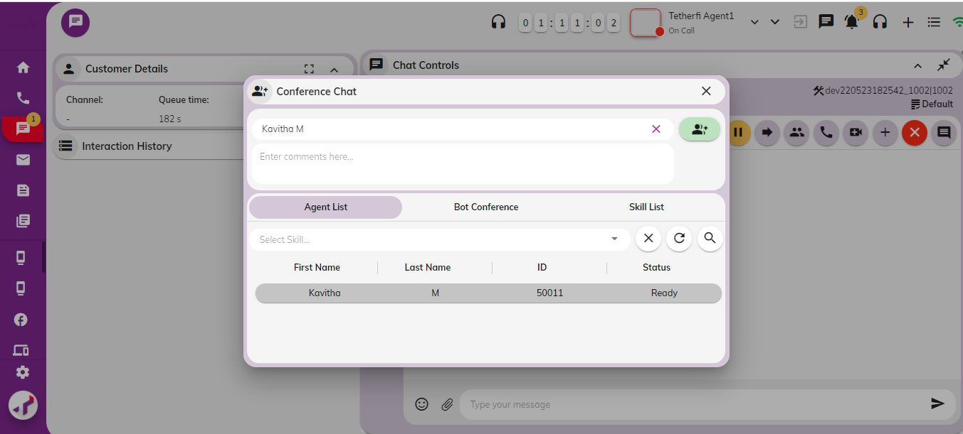

### **Escalate to Audio**

Escalate to Audio the chat will be escalated to customer and the call will be initiated from the agent to customer.

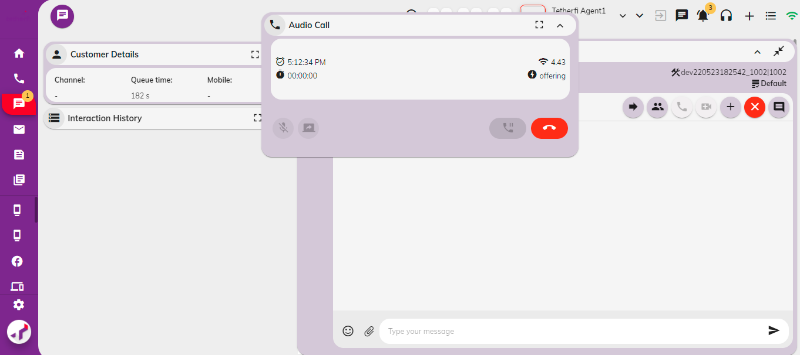

### **Escalate to Video**

Escalate to video the chat will be escalated to customer and the video call will be initiated from the agent to customer.

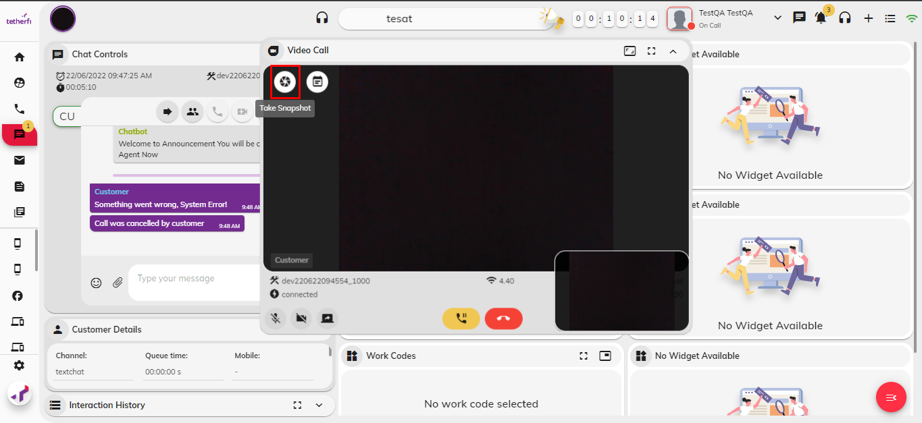

### **Customer Details**

This widget is used to display the customer details currently interacting with the agent. The following customer details are displayed in the page.

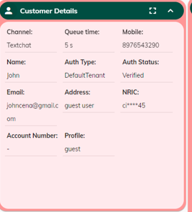

### **Interaction History**

As it may be clear that the interaction widgets are usually displayed during an interaction event i.e., inside the interaction tabs like “Email”, “Chat” and “Voice” and the non-interaction widgets are usually displayed in non-interaction tabs like “Home” and “Workbench”.

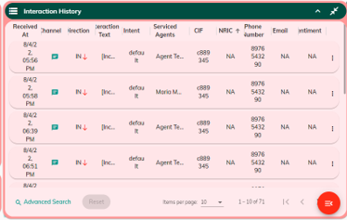

### **Canned Response**

Canned response is the template, which is already created, and the template can be attached to the email chat.

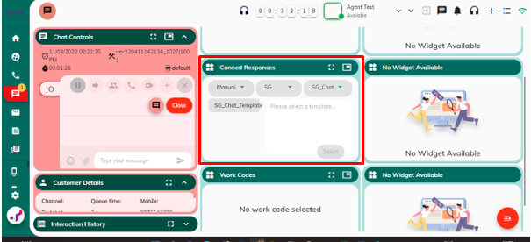

### **Work Codes**

Work codes provide a way to track the different reasons your customers are calling-in. The supervisor can set the different reasons to account for and at the end of each interaction a specific work code can be tagged to the customer call. This widget displays the wrap-up code summary, and it indicates the number of times a specific work code was tagged to an interaction.



## Email Channel

This page provides an intuitive interface to efficiently manage Email with your customer. The primary widgets on the left panel such as Interaction History, canned response and work codes are fixed unlike other widgets that be floated across the page.

### **Email Controls**

The image depicted below represents the view of the Agent when the Email is pulled from the workbench Available state and the chat comes through

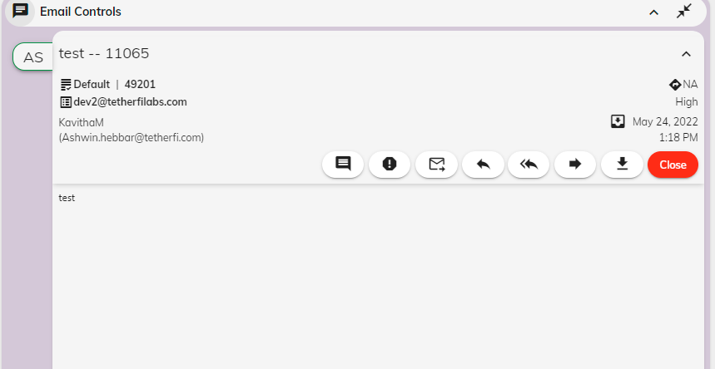

The Email interaction controls available in this widget are listed below:

|  |  |
| --- | --- |
| **Controls** | **Descriptions** |
|  | Click on this button to view the interaction comments |
|  | Click on this button to mark as span |
|  | Click on this button to transfer the email to another agent |
|  | Click on this button to reply to mail |
|  | Click on this button to reply all for the mail |
|  | Click on this button to forward the mail |
|  | Click on this button to download the mail |
|  | Click on this button to close the interaction |

### **Interaction comments**

Interaction comments is the comments made during the email interactions

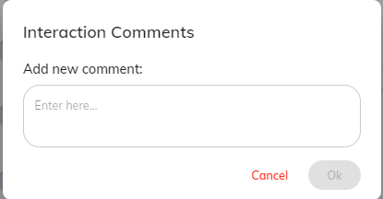

### **Mark as spam**

The selected email will be sent to Spam folder on marking the mail as Spam.

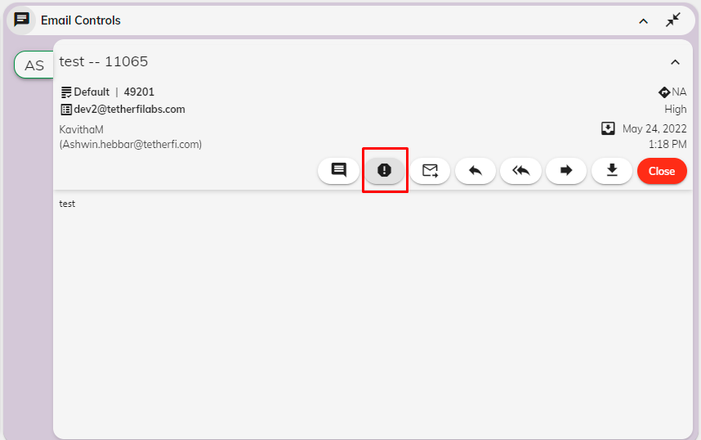

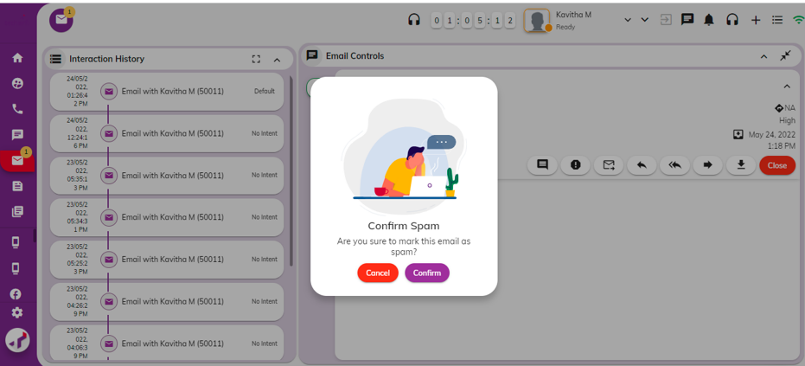

### **Email Transfer**

Email Transfer is necessary for the agent to transfer the email to another agent during the interaction

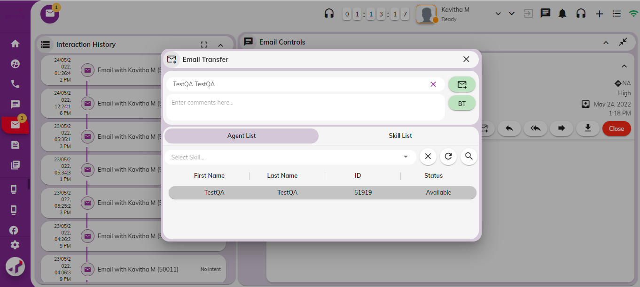

### **Blind Transfer**

A blind transfer is when you transfer the call to a pool of agents or another agent without speaking to the new agent first

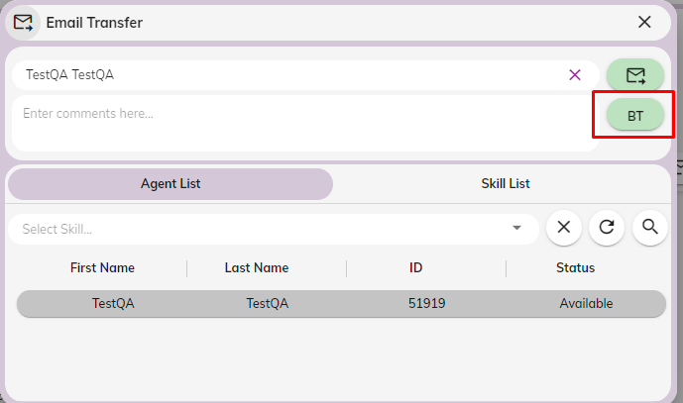

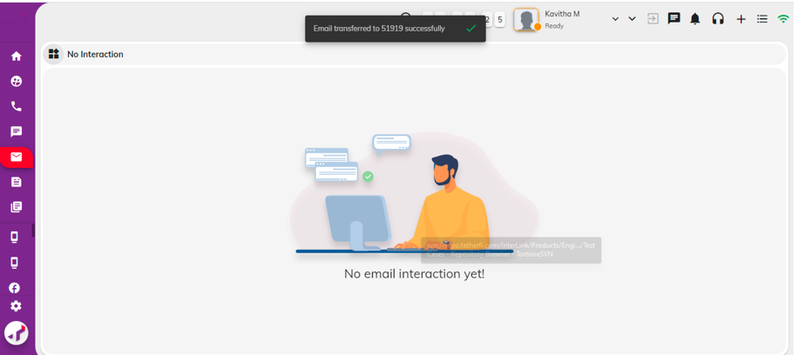

### **Reply**

Agent will reply to the selected email on the interaction with the customer email and the reply will be sent to the customer email address.

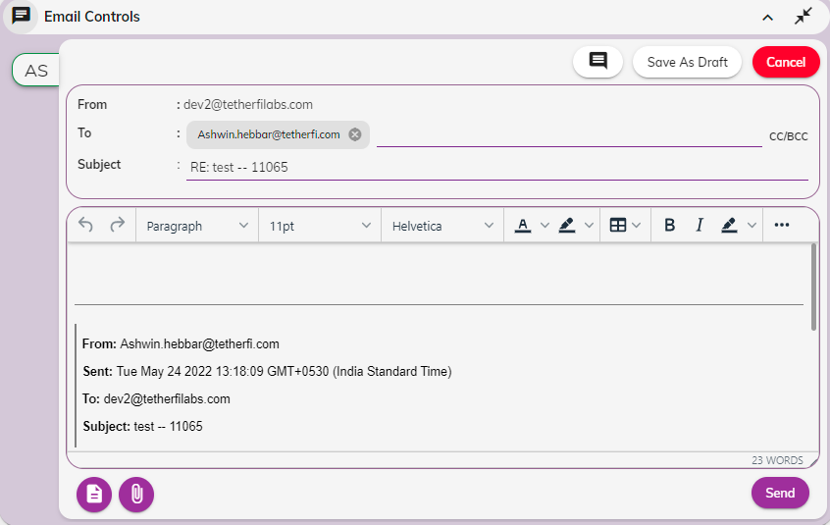

### **Reply All**

Agent will reply to the selected email on the interaction with the customer email and the reply all will be sent to the customer email address.

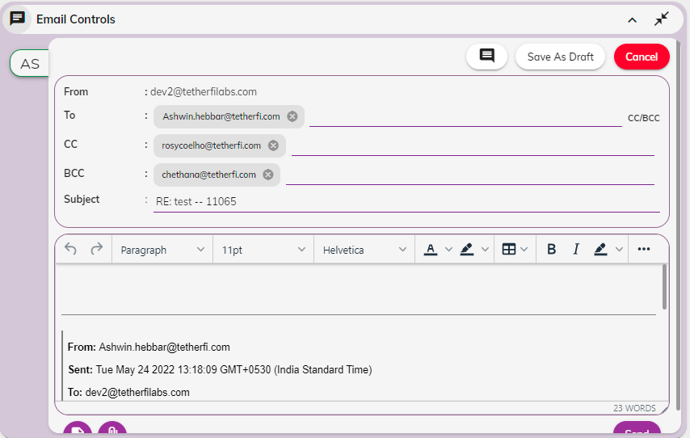

### **Forward email**

Email can be forwarded to another agent during the interaction.

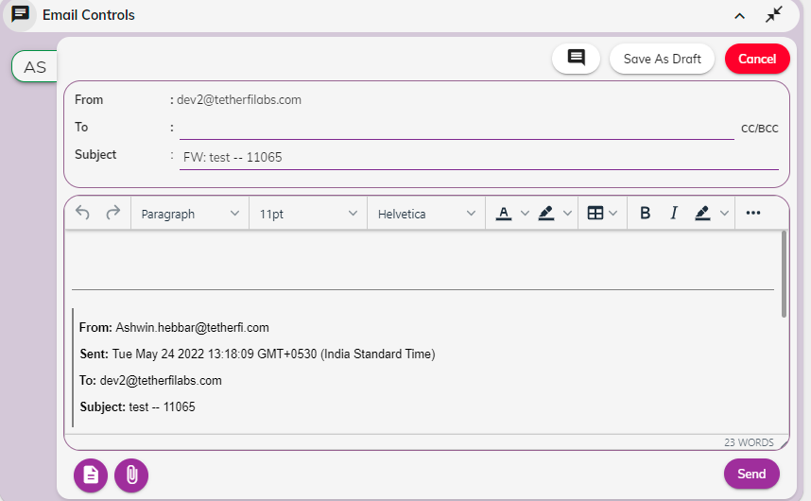

### **Download**

Select email can be downloaded with all the contents with the body of the mail and subject

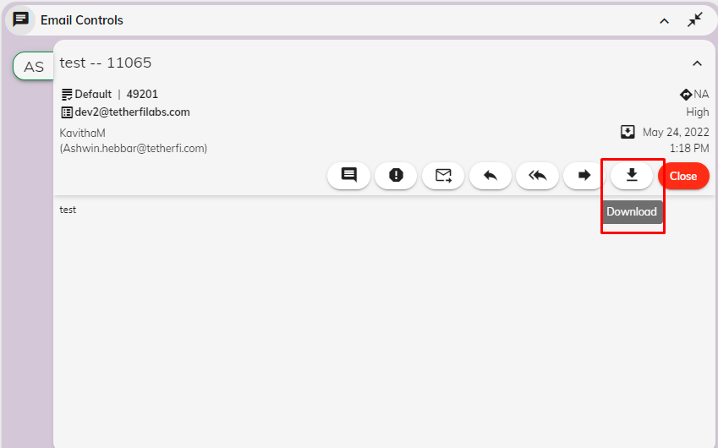

### **Interaction details**

As it may be clear that the interaction widgets are usually displayed during an interaction event i.e., inside the interaction tabs like “Email”, “Chat” and “Voice” and the non-interaction widgets are usually displayed in non-interaction tabs like “Home” and “Workbench”.

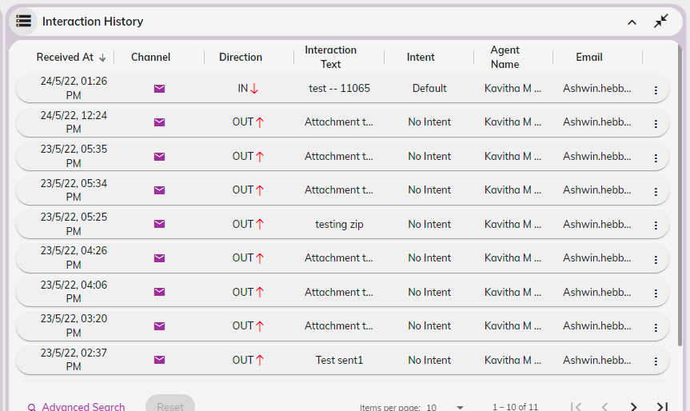

### **Work Codes**

Work codes provide a way to track the different reasons your customers are calling-in. The supervisor can set the different reasons to account for and at the end of each interaction a specific work code can be tagged to the customer call. This widget displays the wrap-up code summary, and it indicates the number of times a specific work code was tagged to an interaction.



## Social Media Channel

Agent Desktop (AD) is being upgraded to include support for social media channels like Instagram, Twitter, and Facebook. Comments from customers on these platforms—such as those on Facebook Business Posts, Twitter Business Tweets, and Instagram Business Posts—will be routed to available agents on the AD. Agents will be able to view and respond to these comments directly through the AD interface, facilitating prompt and effective communication with customers across social media channels.

### **Workbench – Social Media Tab**

When a customer comments or replies on business posts made on Facebook, Instagram, or Twitter, the details of these comments, including information about the post, will be automatically added as interactions within the "Social Media" tab of the Workbench. This applies only to posts from monitored business accounts on the specified social media platforms. Posts created by the business itself will not be routed to the Agent Desktop (AD). Only customer comments and replies on these business posts will be directed to the AD.

#### Social Media Segments

Social Media Interactions will be organized by channels—Facebook, Twitter, and Instagram. Within each channel, interactions will be categorized by skill sets. Each interaction will show the account name of the customer who commented, along with the text of their comment or reply. Clicking on an interaction will reveal details about the post, including the total number of reactions and comments associated with it. Comments or replies related to the selected interaction will be highlighted. The Social Media tab in the Workbench will include the following sections:

1. **Queued**: Contains all unassigned social media interactions.
2. **Inbox**: Includes both assigned and unassigned social media interactions.
3. **Sent**: Displays sent social media interactions.
4. **Drafts**: Contains drafted social media interactions.

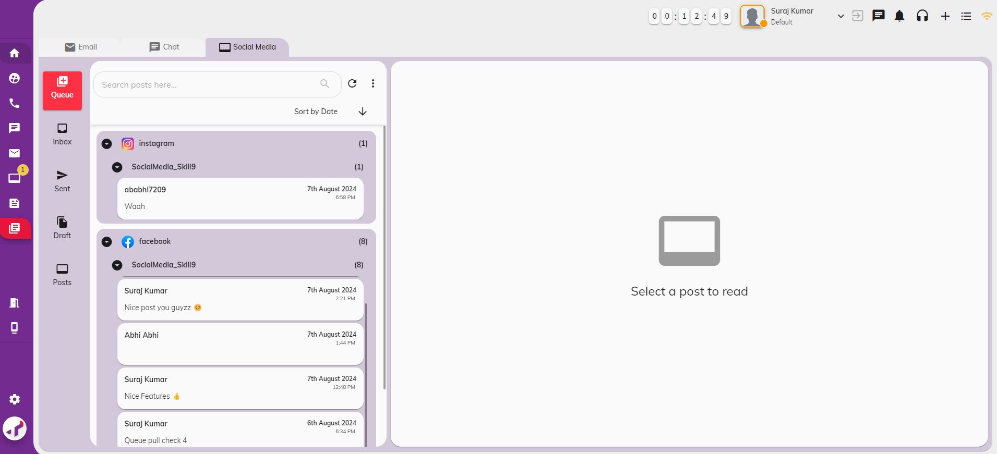

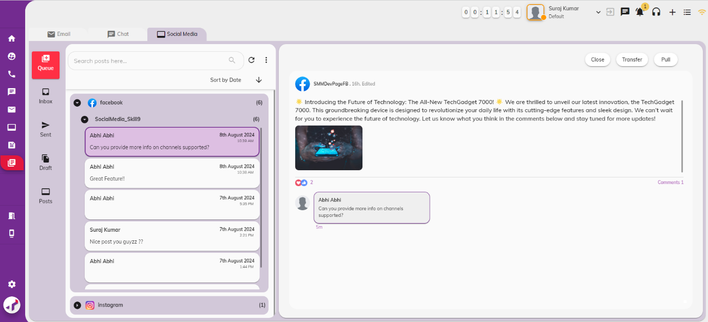

Additionally, there will be a Post section displaying social media posts from Facebook, Instagram, and Twitter. This section will include all posts and their related comments, replies, and reactions created till date for a monitored page, in view-only mode. The purpose of this tab is to showcase posts with or without active interactions.

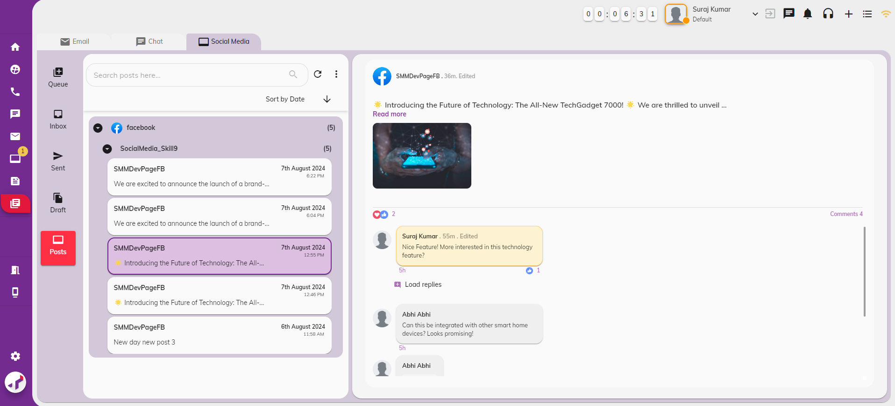

#### Social Media Interaction Controls

Agents can take the following actions on social media interactions in workbench:

1. **Pull Interaction** - Pull the current interaction to respond to the post comment.

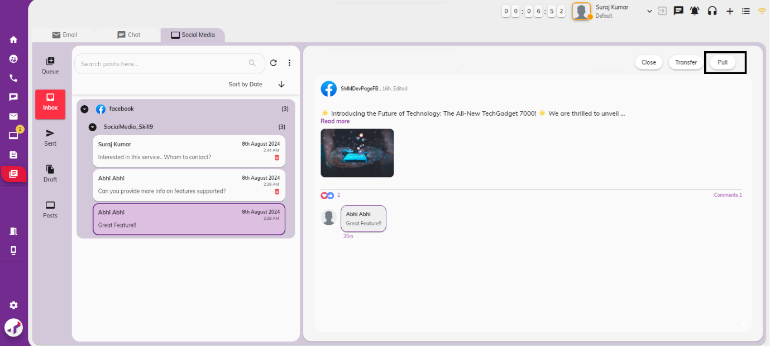

Pulled interaction will be assigned to agent and will be displayed in Social Media Interaction tab.

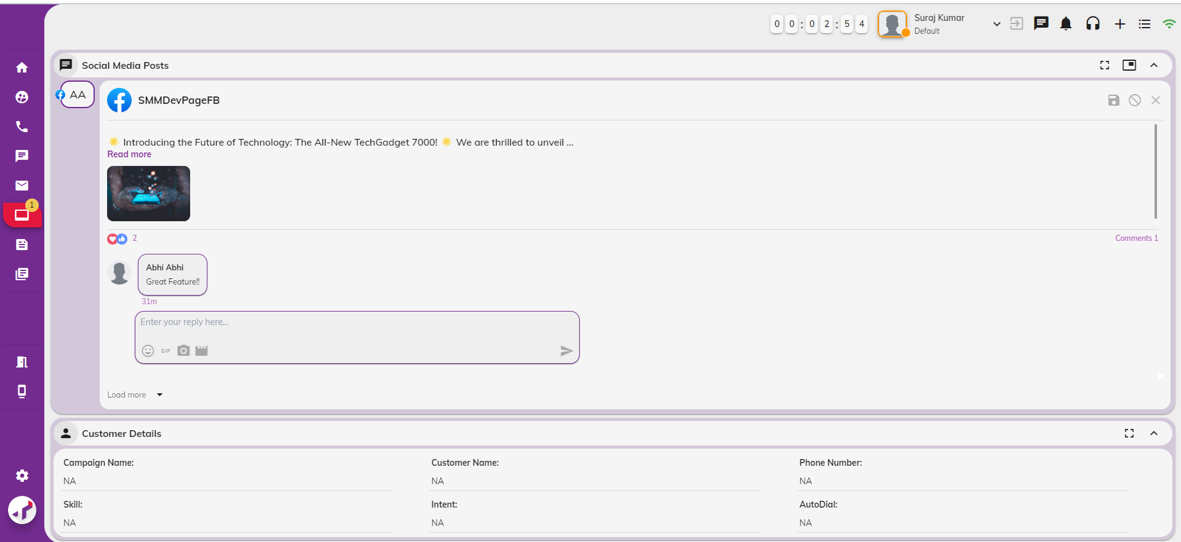

1. **Transfer Interaction** - Forward the interaction to another agent.

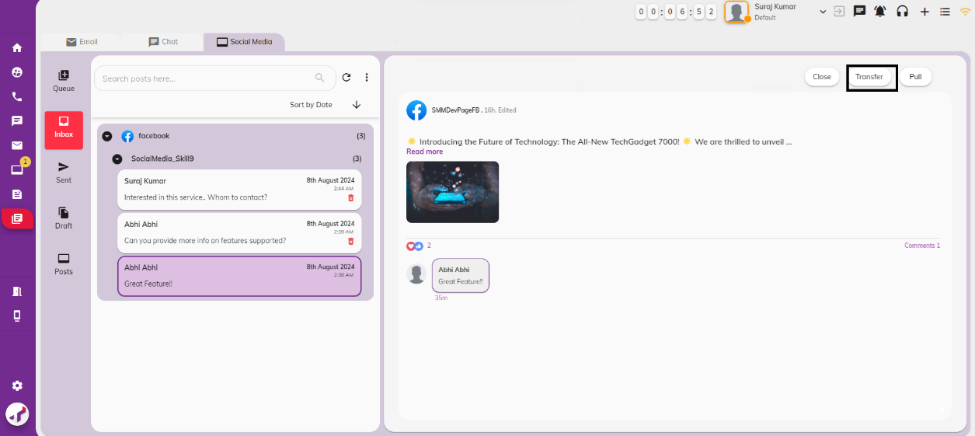

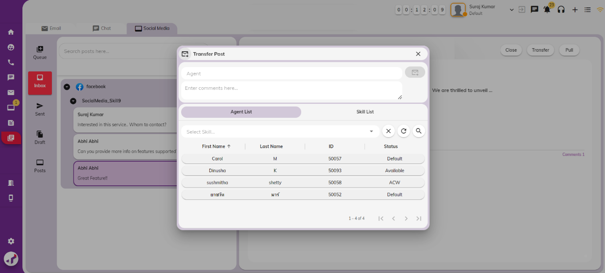

1. **Close Interaction** - Close Interaction without responding to customer comments.

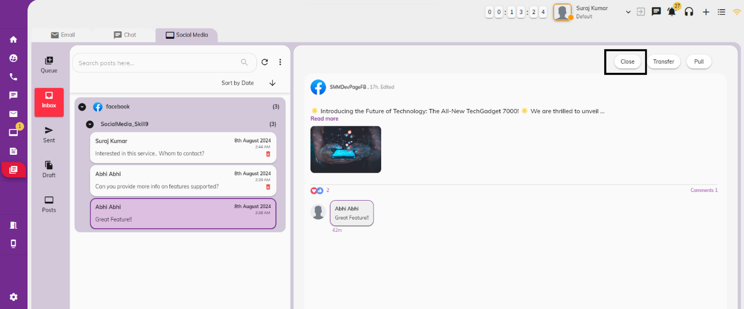

#### Social Media Actions

When actions such as editing, deleting posts or their comments and replies, or reacting to post comments or replies occur on social media platforms for interactions already active in the Workbench, the Agent Desktop will reflect these changes as follows:

1. **Reactions on posts on Social Media Platform**

If any reactions are added to posts in social media channel, agents will receive notifications.



Clicking on the notification will open the Posts section of Workbench, highlighting the relevant post and their reactions.

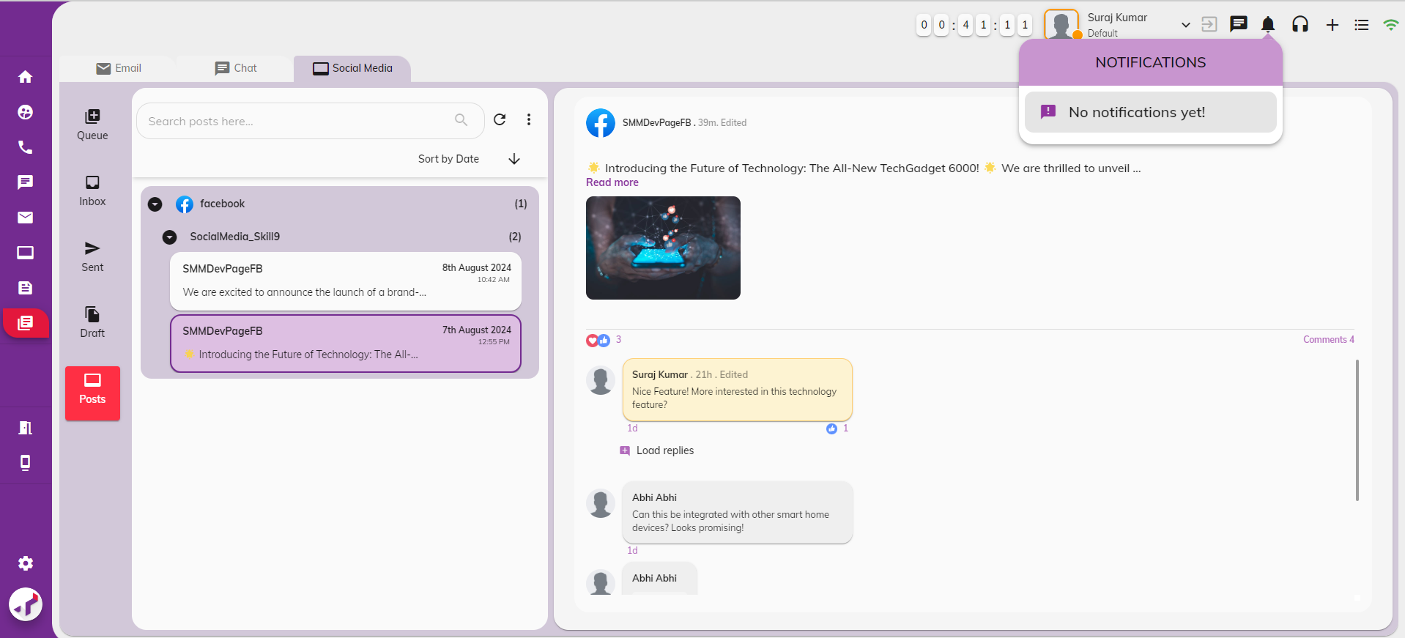

1. **Reactions on comments or replies on Social Media Platform**

If any reactions are added to comments or replies in social media channel, agents will receive notifications.

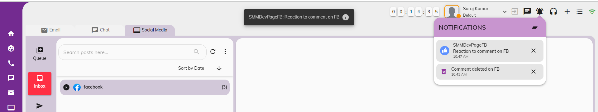

Clicking the notification will open the Inbox section of Workbench, highlighting the relevant comments and their reactions.

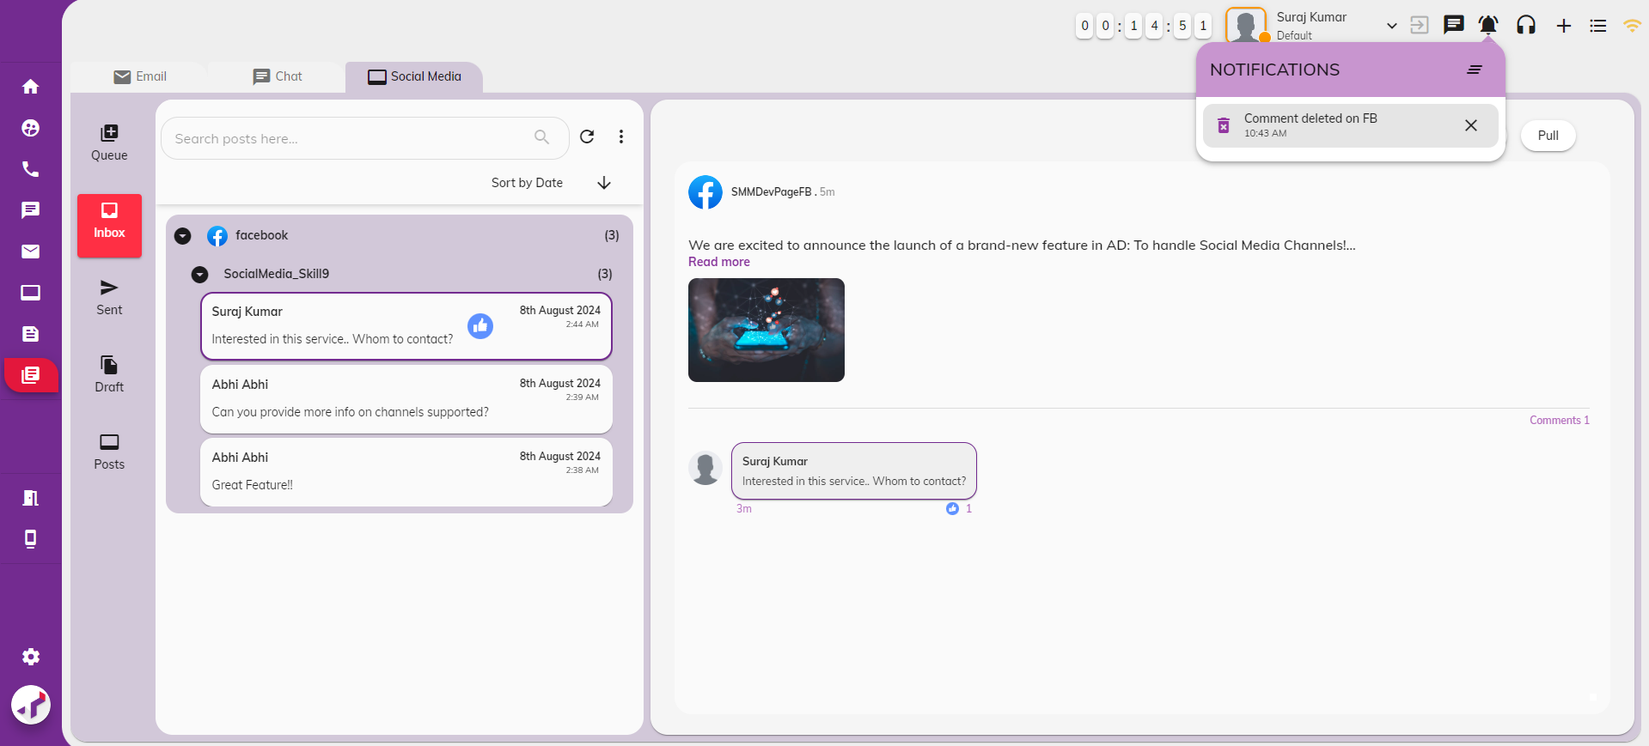

1. **Edit Posts on Social Media Platform**

When a post on social media is edited, a notification will be sent to agents in AD.

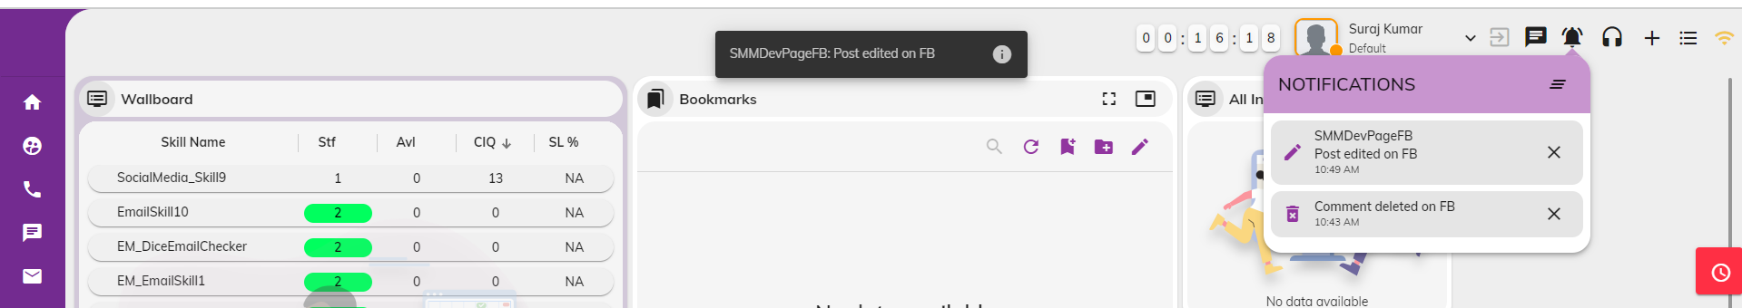

Clicking the notification will redirect agents to the Posts section of the Workbench, where the current edited Post will be highlighted and displayed. Edit Icon will be updated for post. Old post contents will not be shown.

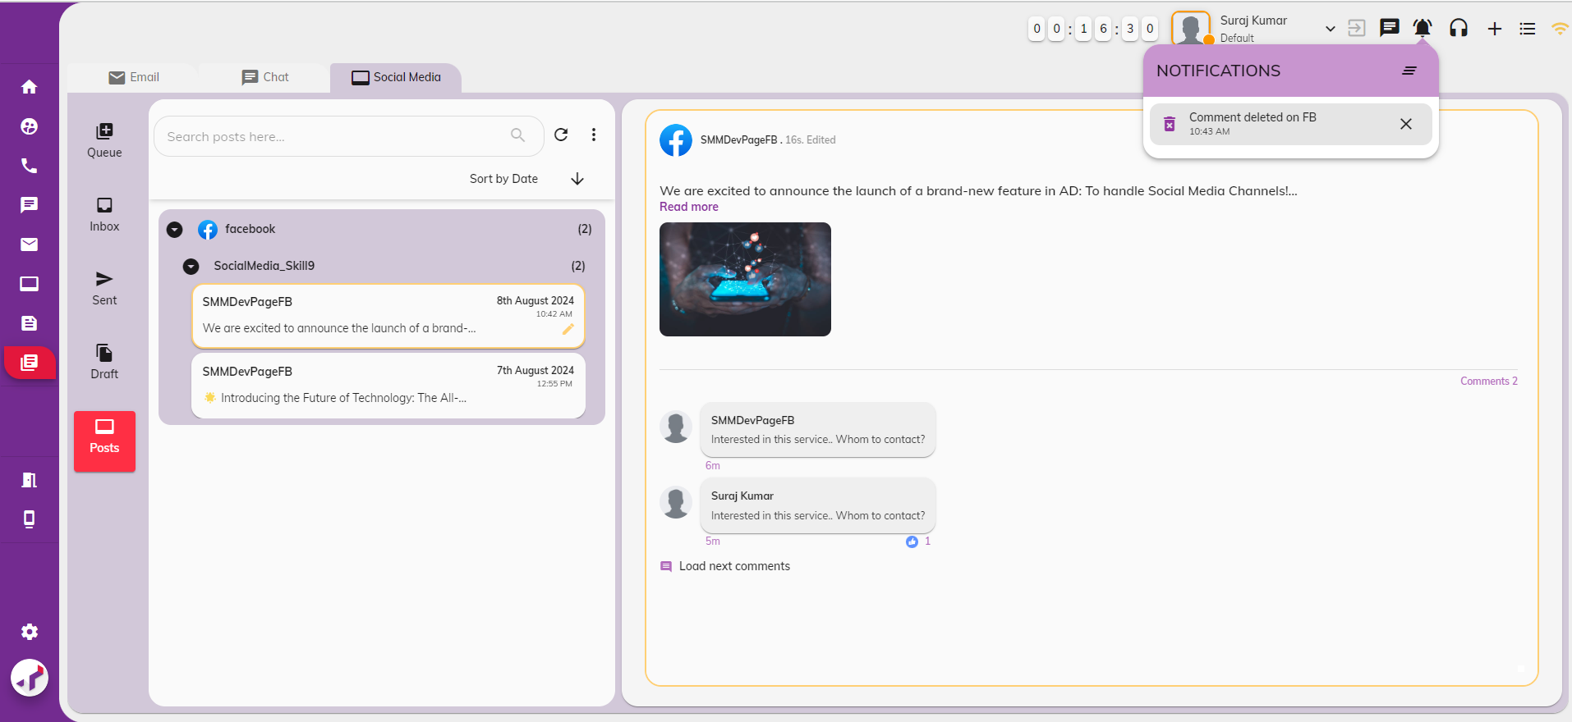

1. **Edit comments or replies on Social Media Platform**

When a comment or reply is edited on social media platform, a notification will be sent to agents in AD.

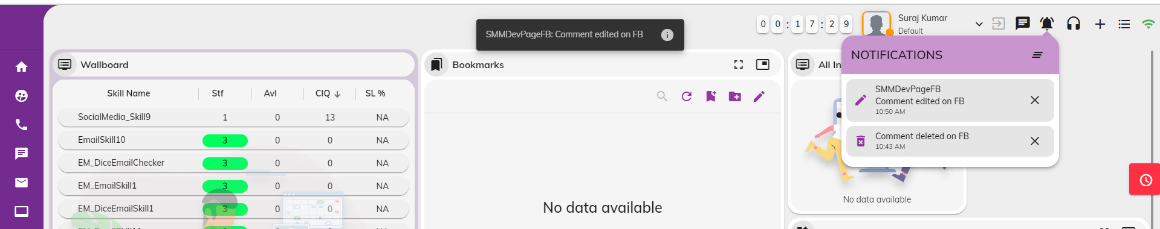

Clicking the notification will redirect agents to the Inbox section of the Workbench, where the current edited comment will be highlighted and displayed. Edit Icon will be updated for comment.

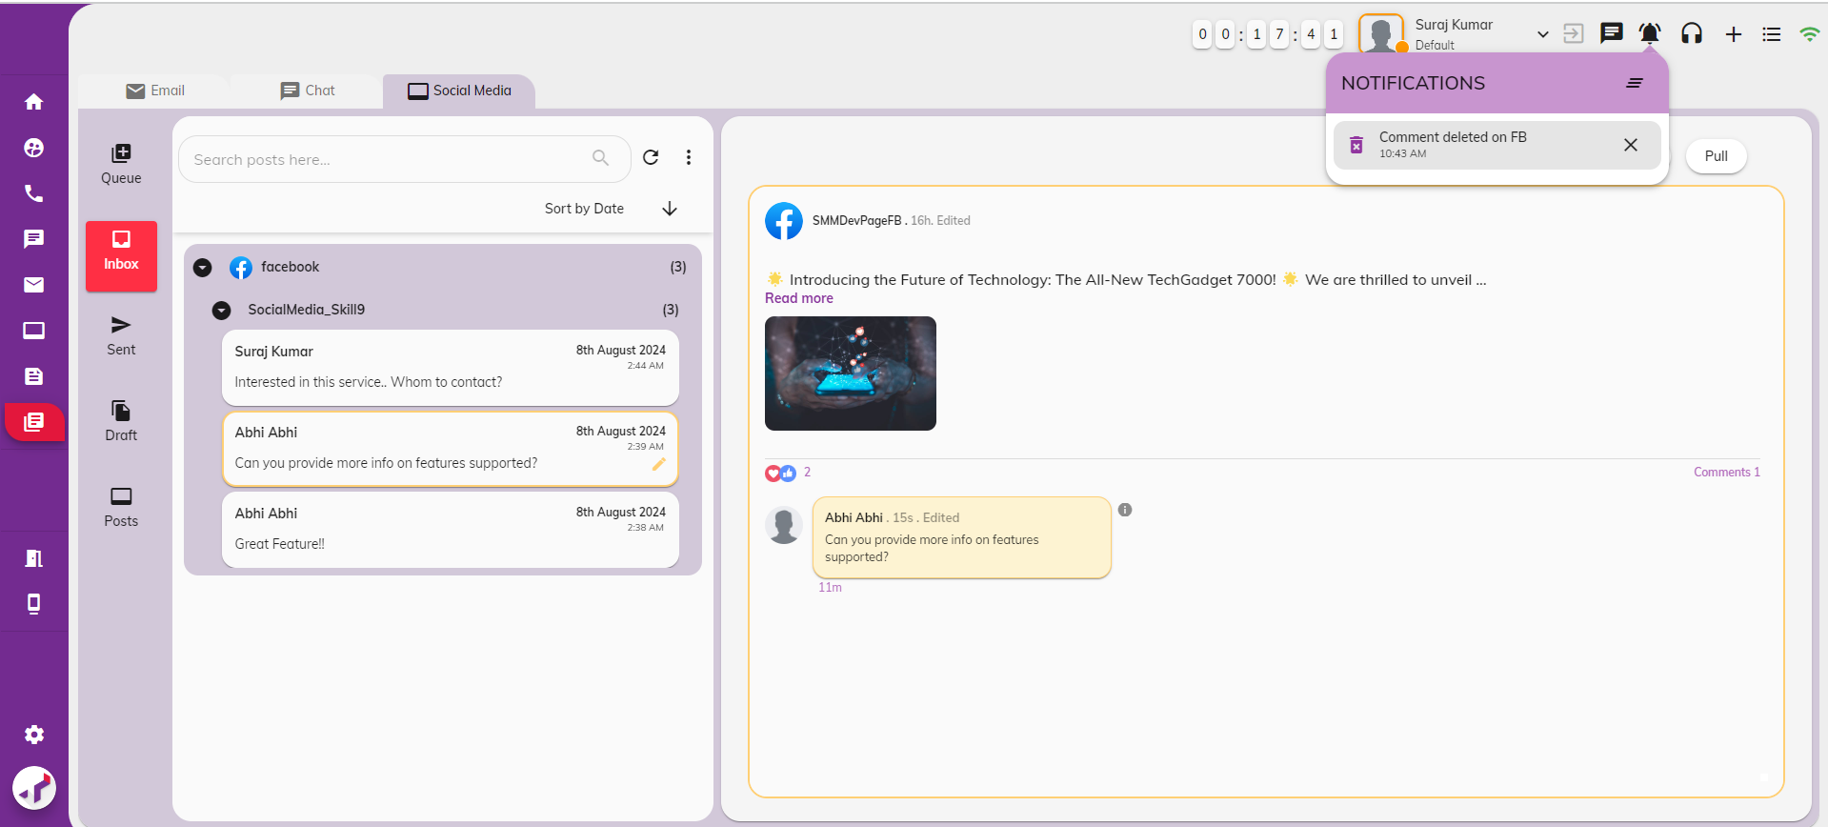

Clicking on the ‘i’ icon will display the most recent version of the comment or reply that was last edited. This information will be shown only once and will disappear once you navigate to other interactions.

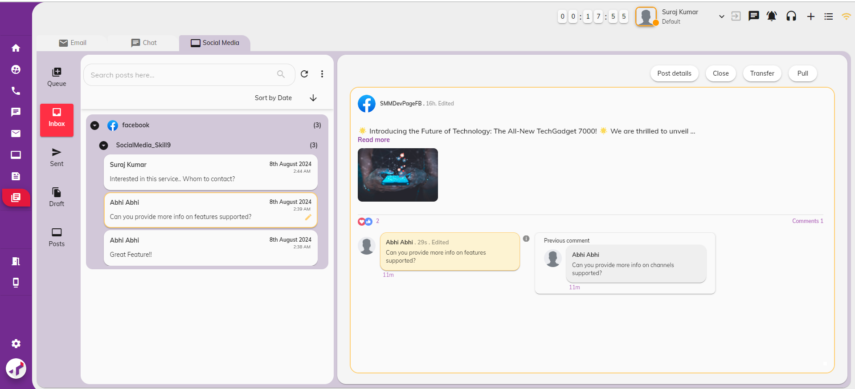

1. **Delete Posts on Social Media Platform**

When a post is deleted on social media platform, a notification will be sent to agents in AD.

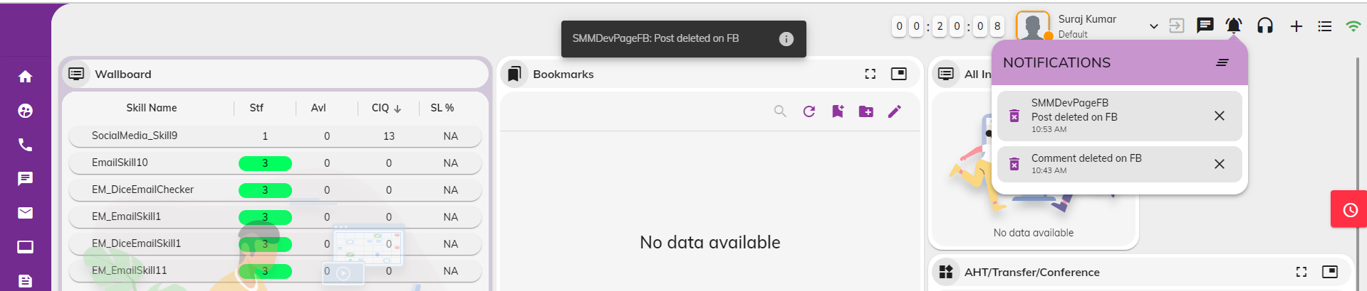

Clicking the notification will direct agents to the Posts section of the Workbench, where the currently deleted post will be highlighted and displayed. Posts and comments will remain in the Workbench; however, a Deleted Icon will appear for the post across all sections (Queue, Inbox, Sent, Drafts, Posts). The actions—Transfer, Pull, and Close—will be disabled for these posts.

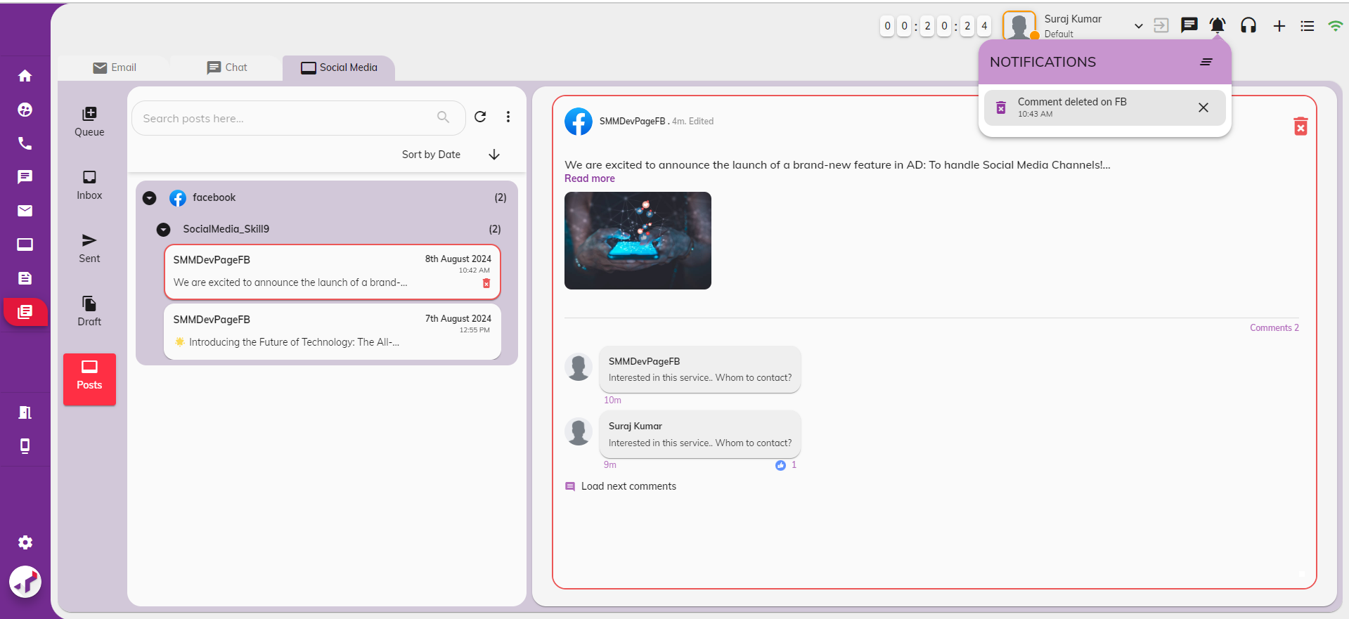

1. **Delete comment or replies on Social Media Platform**

When comments or replies are deleted, a notification will be sent to agents in AD.

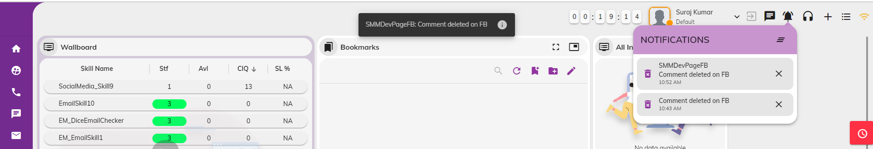

Clicking the notification will direct agents to the Inbox section of the Workbench, where the currently deleted comment/reply will be highlighted and displayed. Posts and comments will remain in the Workbench; however, a Deleted Icon will appear for the comment across all sections (Queue, Inbox, Sent, Drafts, Posts). The actions—Transfer, Pull, and Close—will be disabled for these interactions.

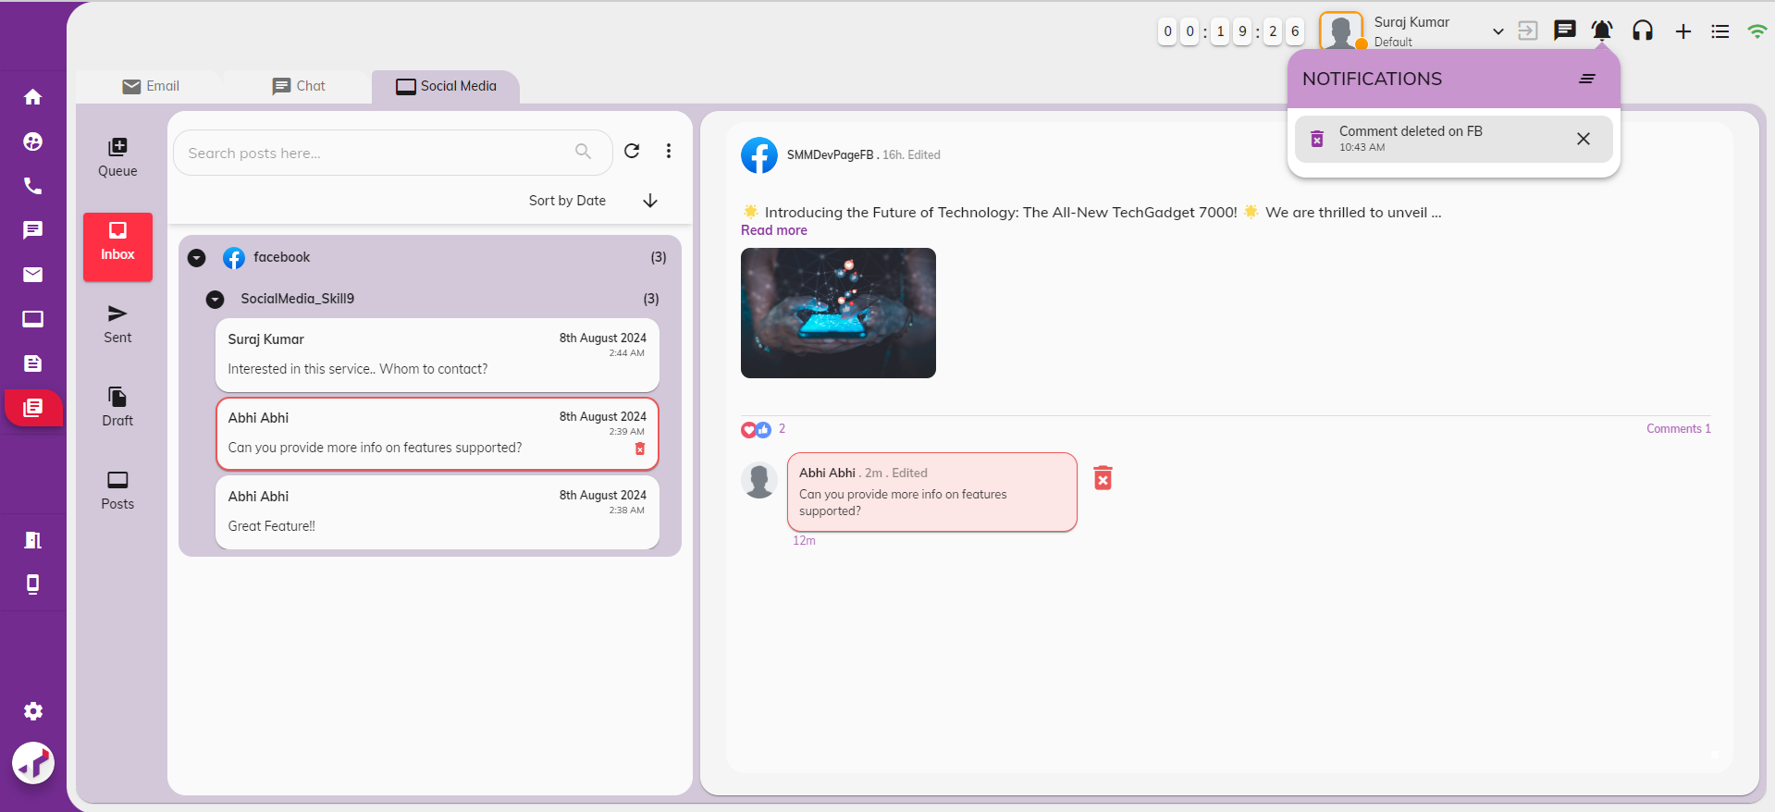

### **Social Media Interactions Tab**

#### Social Media Interactions - Restored Mode

Social Media Posts widget will initially be in restored mode by default. Agents can switch it to maximized mode or floating window mode. Social Media Interactions will be categorized by channel (Facebook, Instagram, Twitter) and displayed to agents.

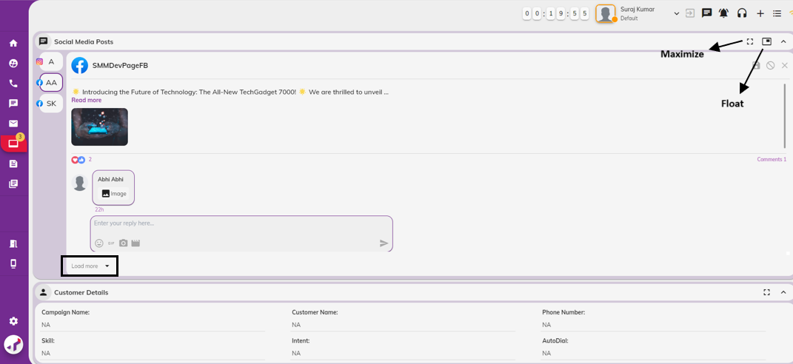

For each interaction, the following details will be shown to the agent:

* **Post Details:** Includes the post contents, total post reactions, total post comments, active comment, active comment reactions (if any) and a section for the agent to reply.
* **Agent Actions:**
  + Send Agent Replies for customer comments from AD and will be posted in social media platform.
  + Save to Draft .
  + Clear Agent Replies.
  + Close current interaction without responding.
* **Load More Option:**
  + On clicking ‘Load more’ option, a popup will be opened for the current social media interaction, providing more details on the comments section than the restored mode. Agents can view additional comments/replies on the current posts before replying to the interaction.

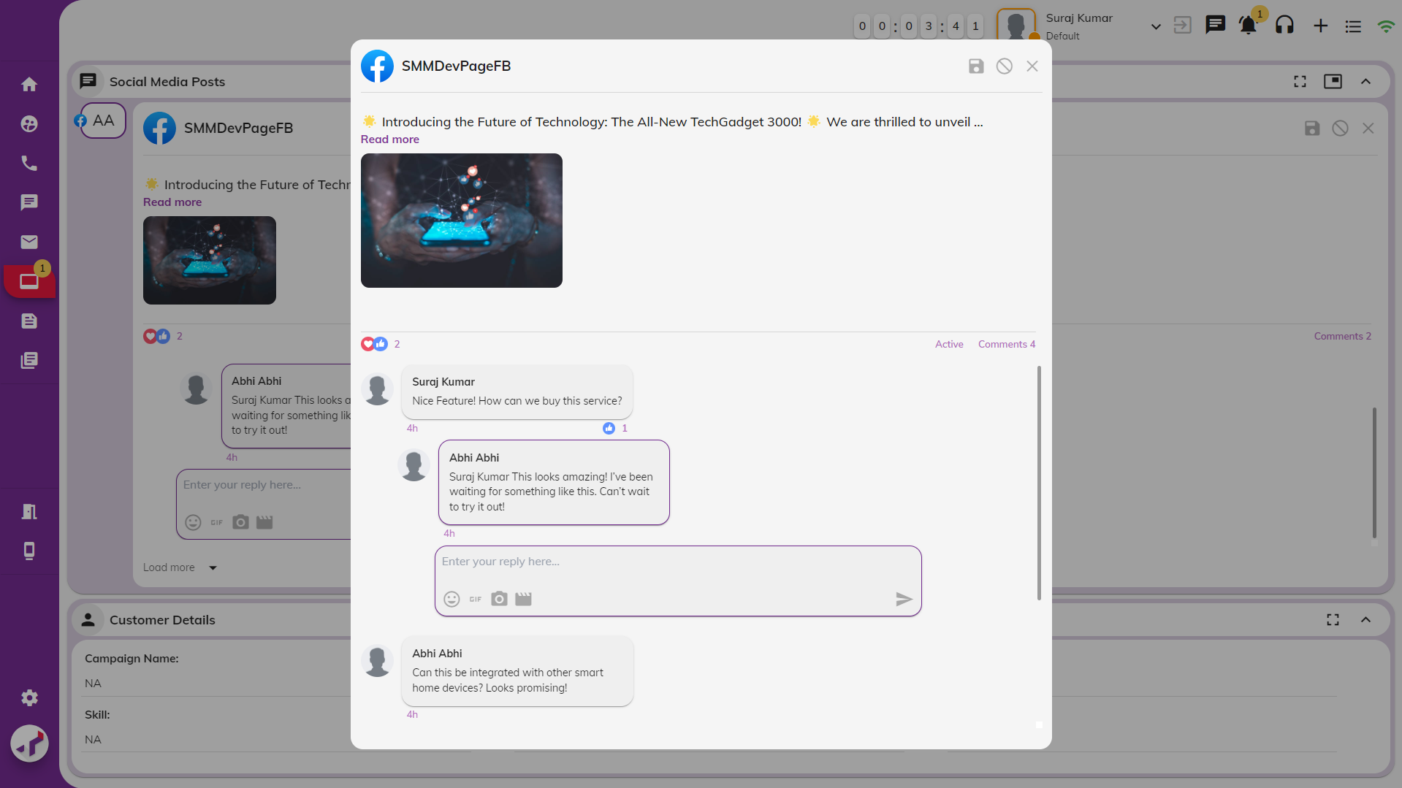

* + Agents can view all comments/replies on the post and can return to the current comment by scrolling back or clicking on the 'Active' link located before Total Post Comments.

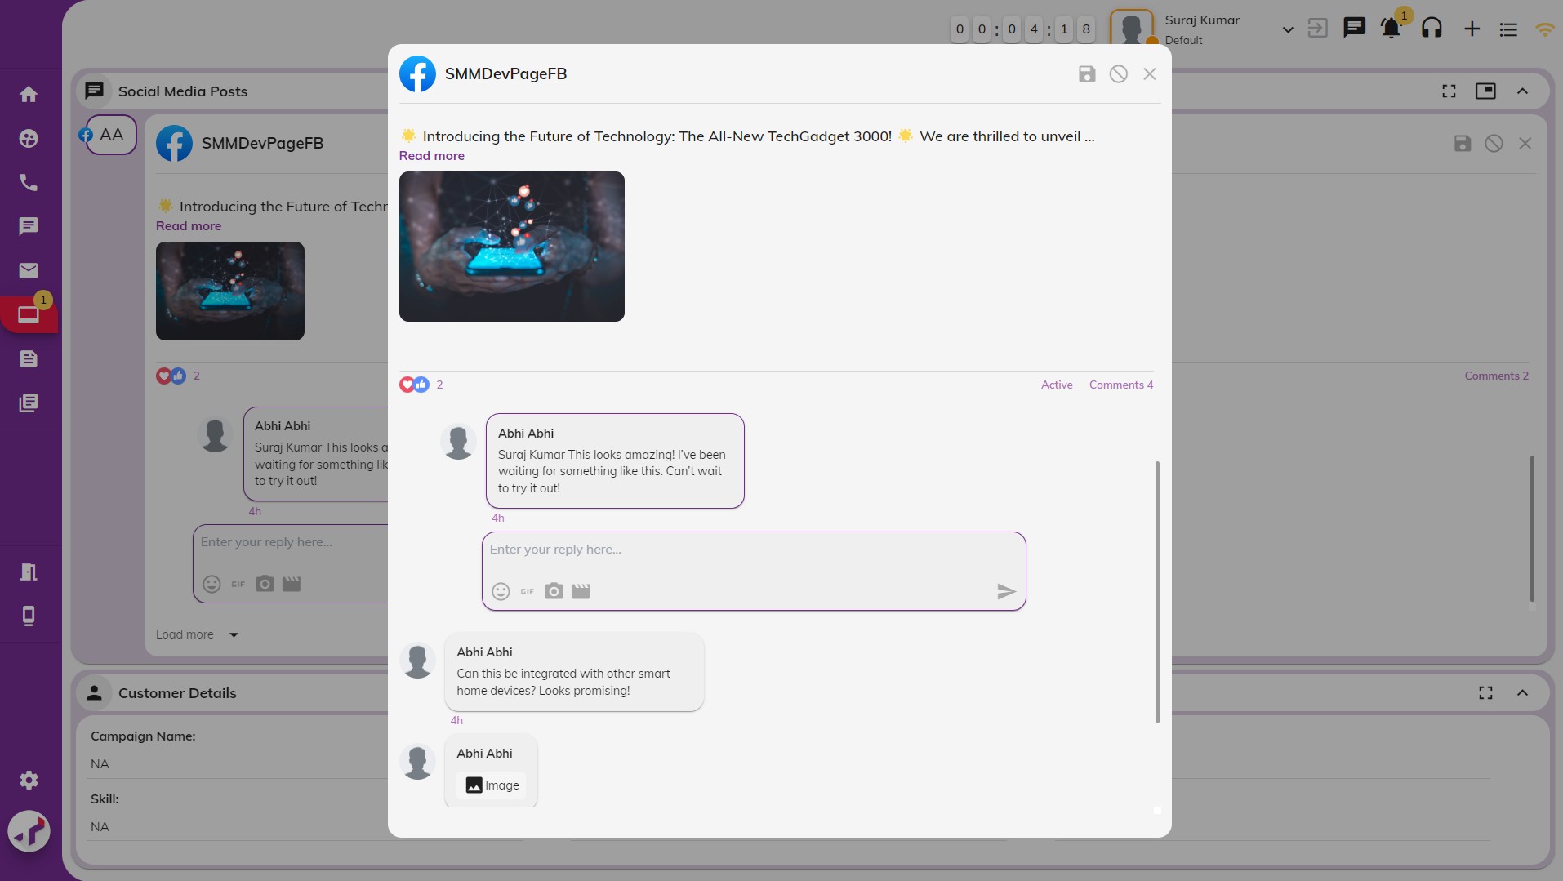

* + Media files (photos, videos, GIFs, etc.) from customer comments will not be preloaded. An icon will be shown and on clicking this icon, media will be downloaded and shown in agent desktop.

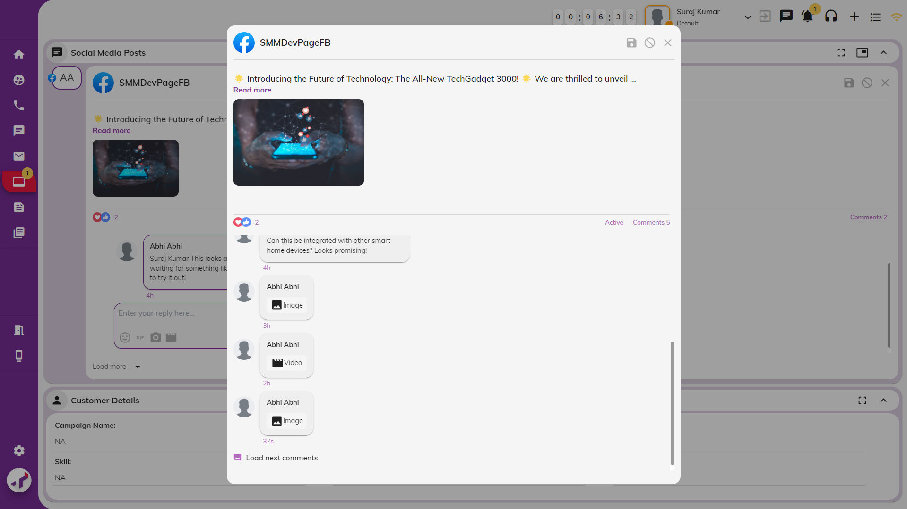

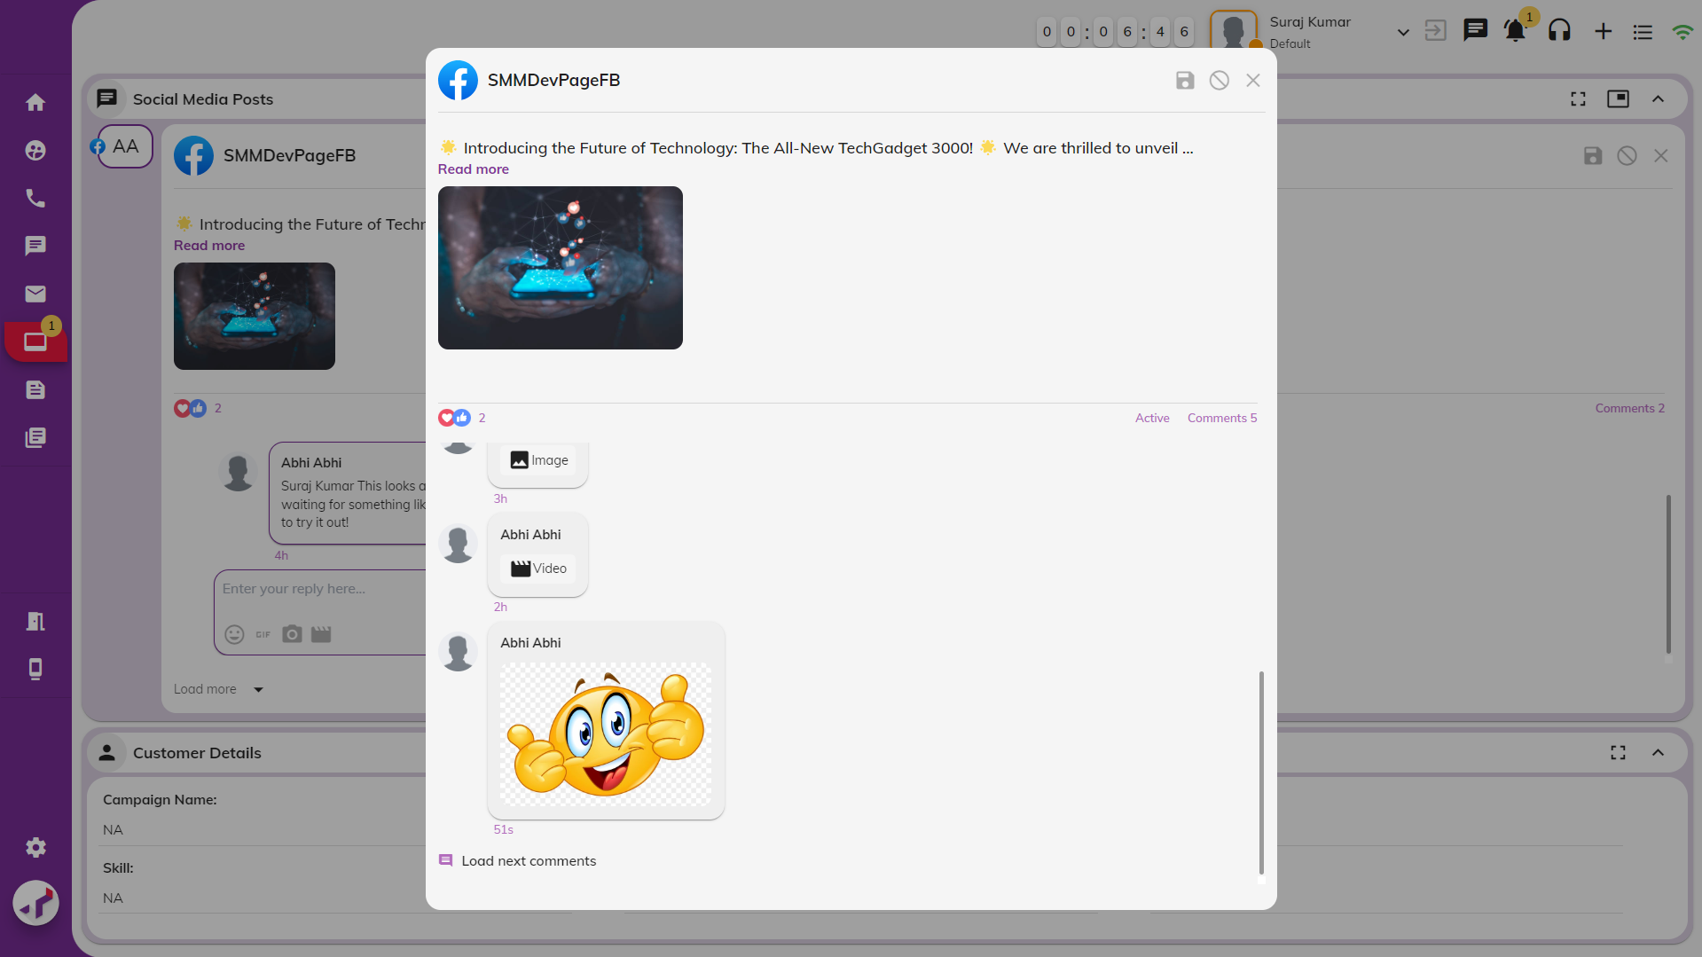

#### Social Media Controls

Agent can perform below actions –

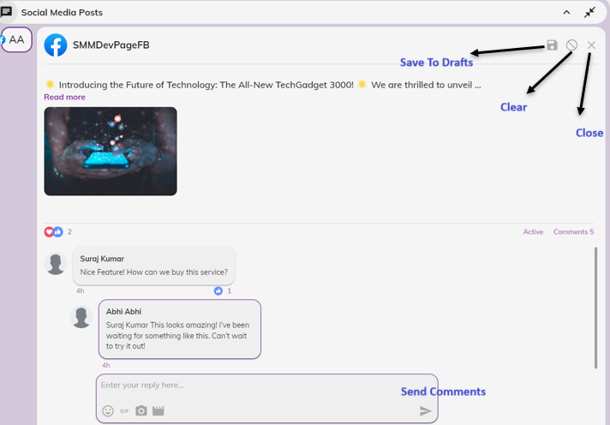

1. **Send Replies to Customer Comments:**

Agents can use text, images, videos, GIFs and emojis in their replies from AD.

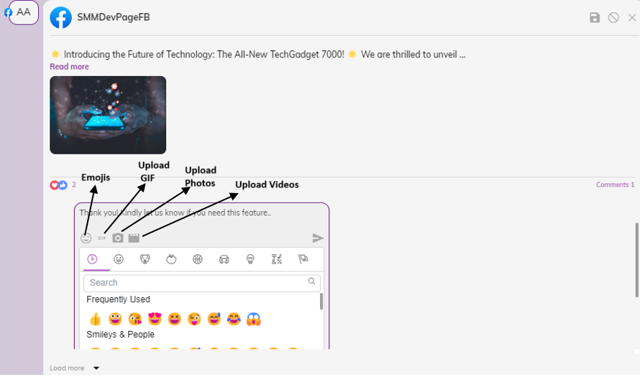

Agents can reply to the current customer’s comment and click on "Send Comments".

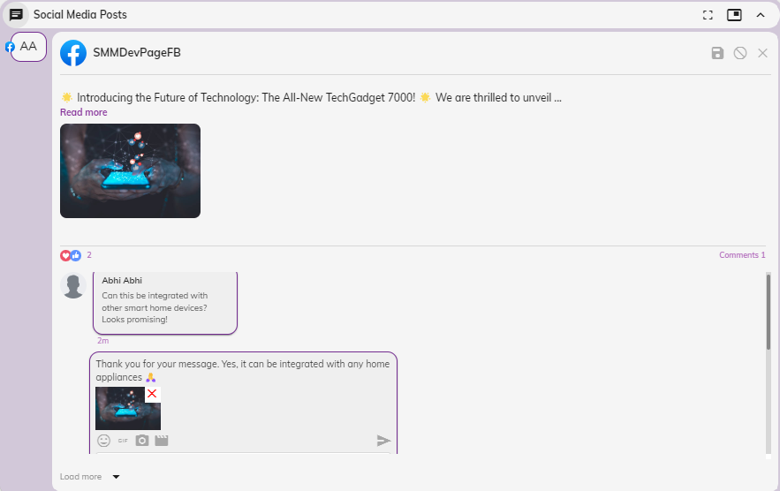

The agent's comment will be posted on social media as a reply to the customer’s comment.

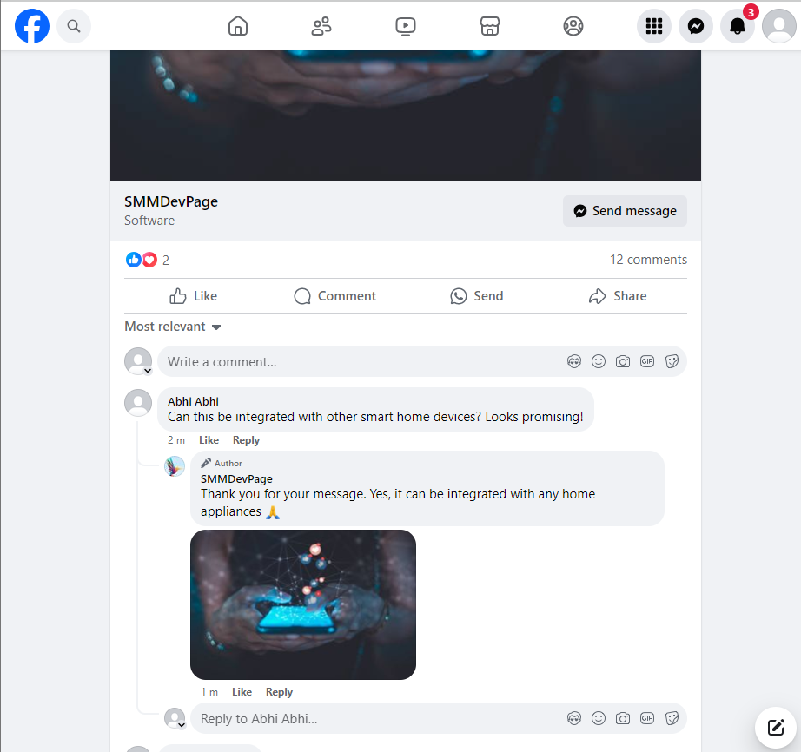

After the agent sends a reply, the interaction will be closed. Both customer and agent comments can be viewed in the Sent Items section of the Workbench.

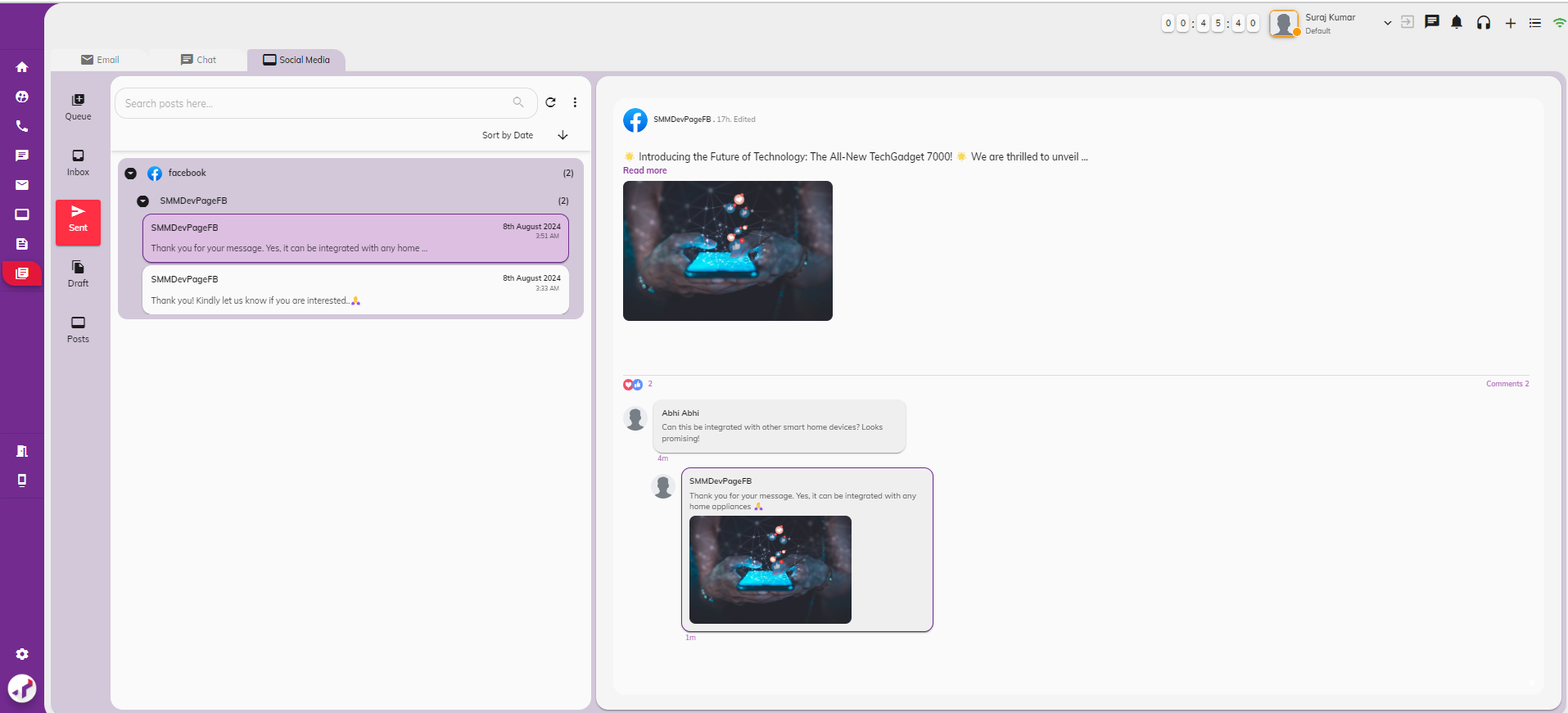

Post Admin can edit an agent’s reply directly from social media (in case of any mistakes, errors, or incorrect information in the previously posted comment from AD).

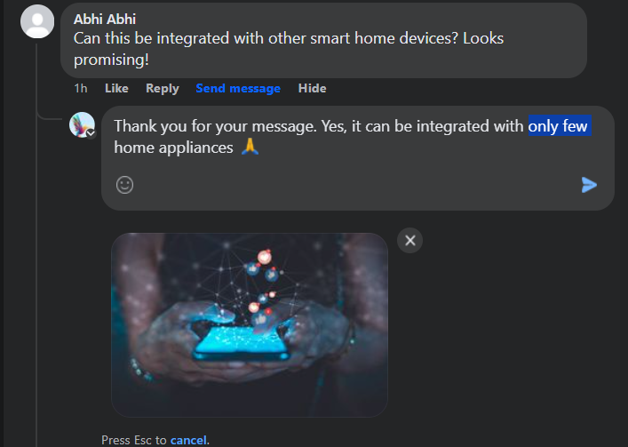

When an edit is made on social media on agent’s reply, a notification will be sent to agents in AD.



Clicking on the notification will redirect them to the Sent Items section of the Workbench, where the current edited comments along with the post will be displayed.

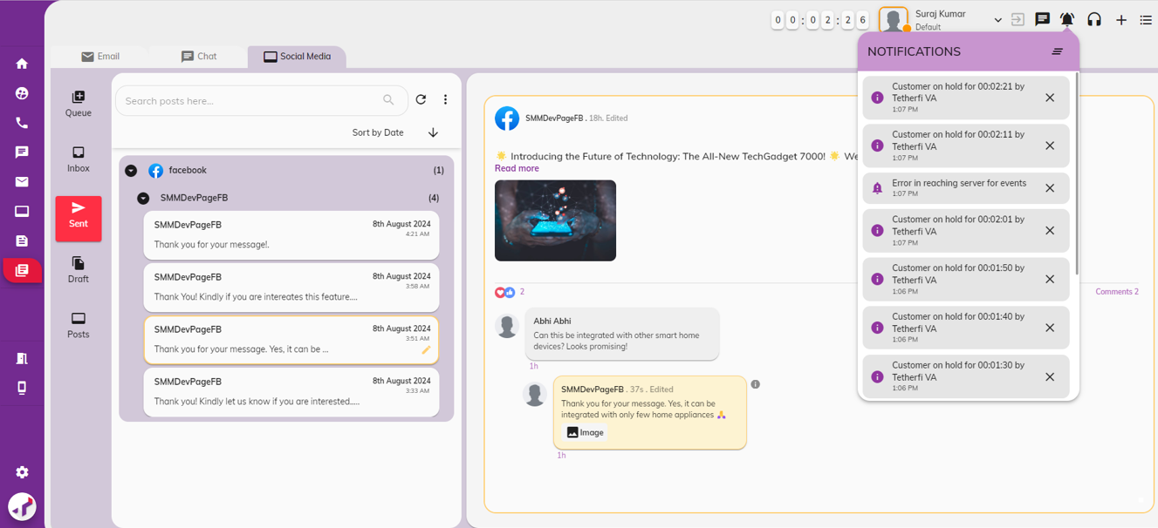

1. **Save to Draft:**

Agents can save replies as drafts to be sent later. To draft a reply, agents must click this button; replies will not be auto drafted.

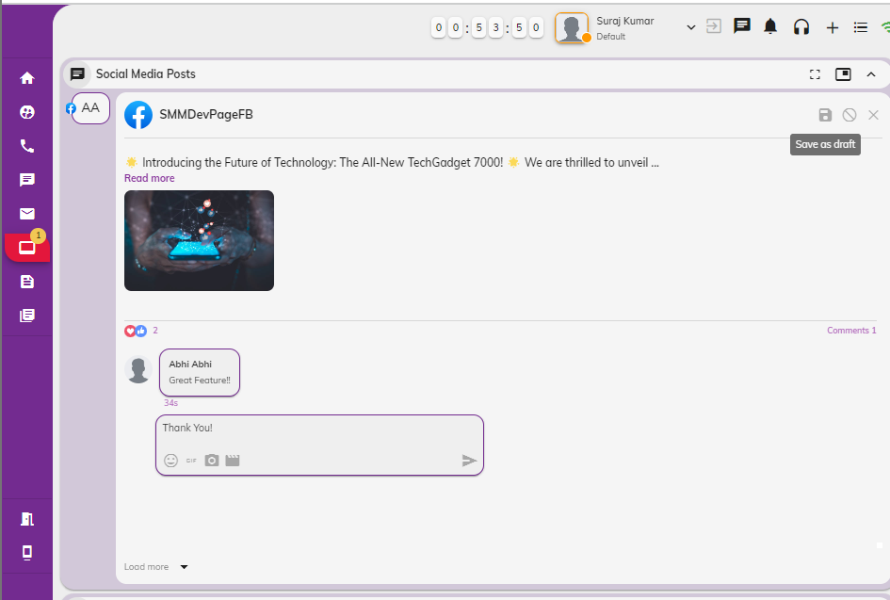

Agents can retrieve drafted replies from the Draft section of the Workbench.

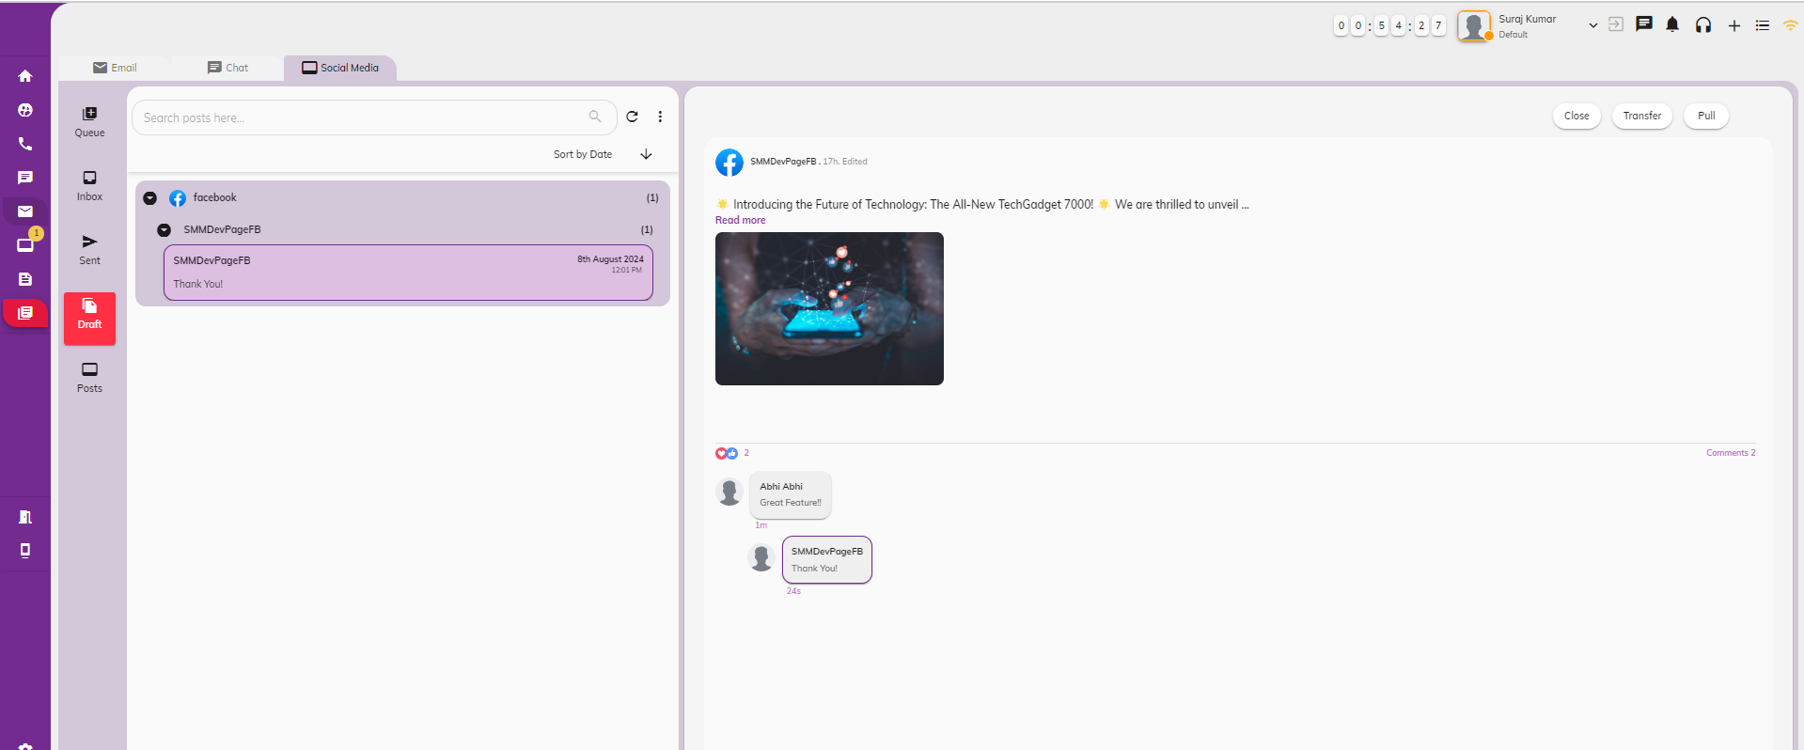

1. **Clear Data:**

Agents can clear replies by clicking this button.

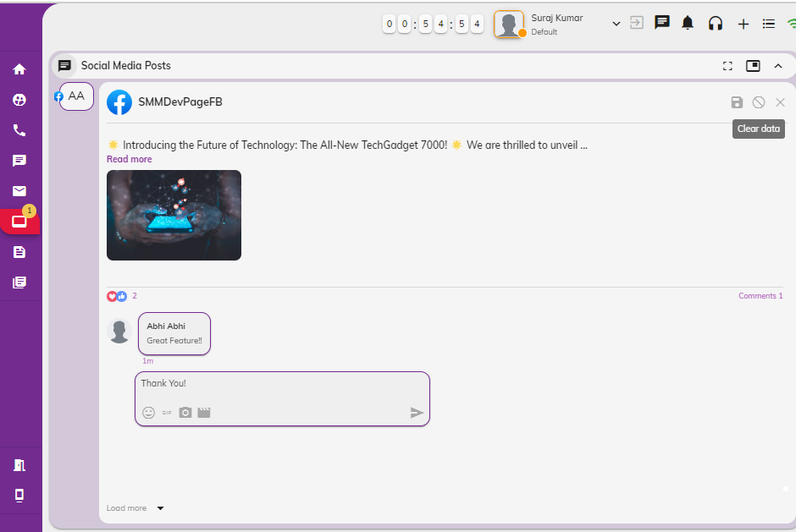

1. **Close Interaction:**

Agents can close pulled interaction without replying. Not all customer comments require a reply, such as comments like "Great" or "Nice".

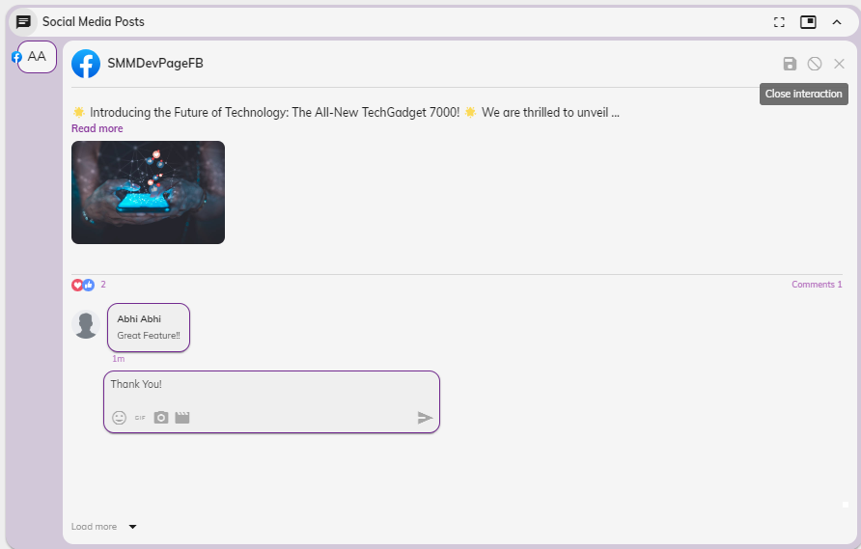

#### Social Media Interaction – Maximized mode

When the maximized window is selected in the Social Media Posts Widget within the Social Media Interaction tab, the following screen will be displayed. All social media interactions will be shown in the maximized window.

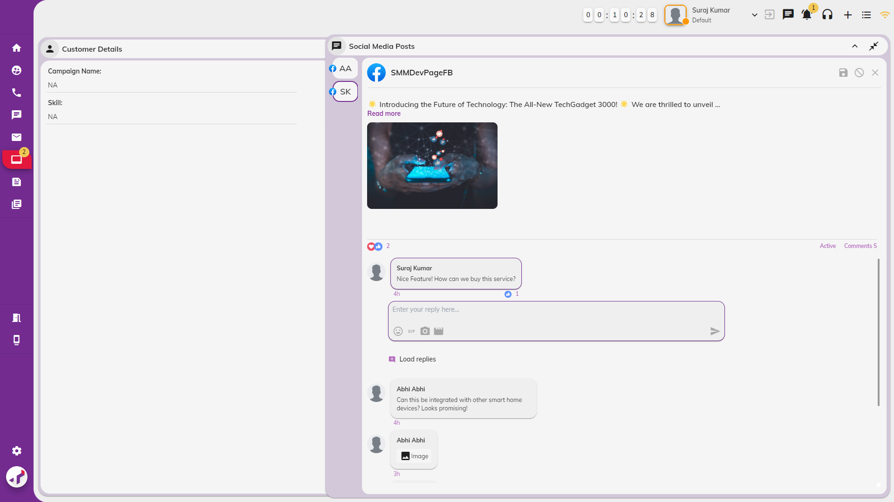

#### Social Media Interaction – Floating Window

When the pop out window is clicked on the Social Media Posts Widget in Social Media Interaction tab, the screen below will be displayed. All social media interactions will be shown in a popped-out window.

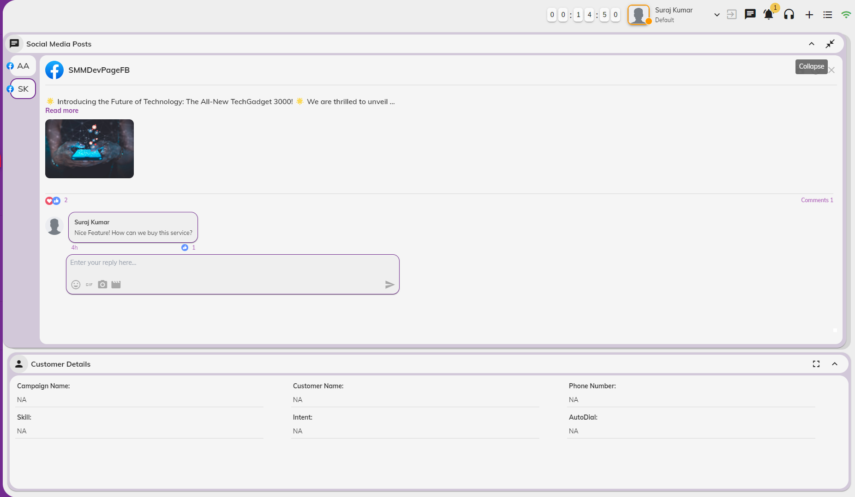

#### Social Media Actions

When actions such as editing, deleting posts or their comments and replies, or reacting to post comments or replies occur on social media platforms for interactions already active in the social media tab, the Agent Desktop will reflect these changes as follows:

1. **Edit Posts on Social Media Platform**

When a post on social media is edited, the popup message – ‘*Post has been edited!* ‘will be displayed for current interaction. A notification will also be sent to agents in AD.

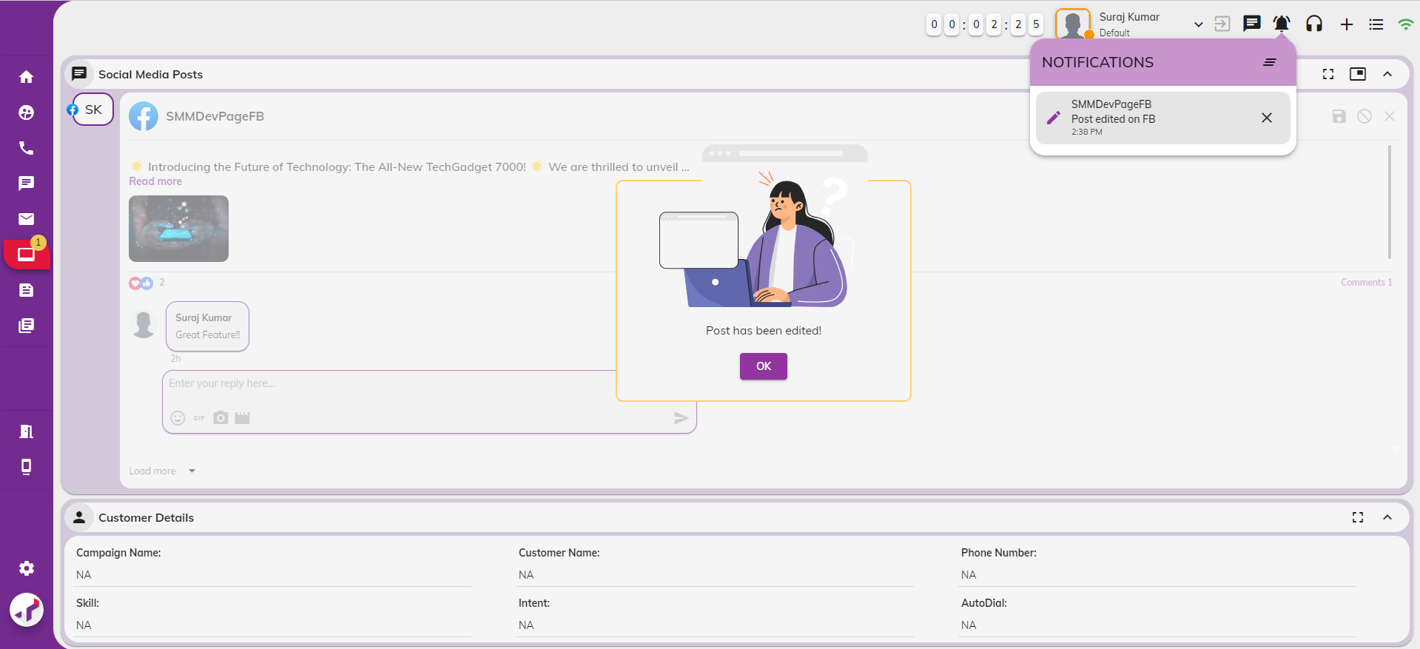

Next, edited posts will be refreshed in social media posts widgets in social media interaction tab.

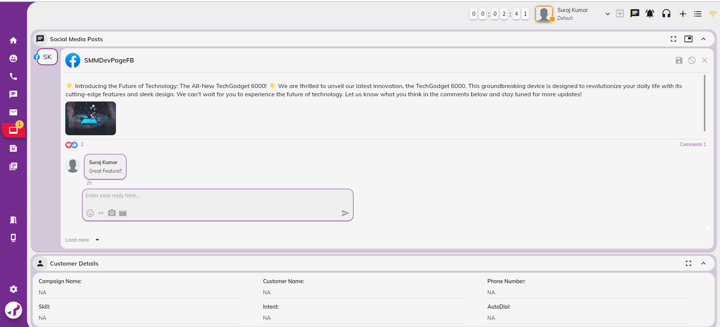

Clicking the notification will take agents to the Posts section of the Workbench, where the recently edited post will be highlighted and displayed. The Edit Icon will be updated to reflect the changes, and the previous contents of the post will not be shown.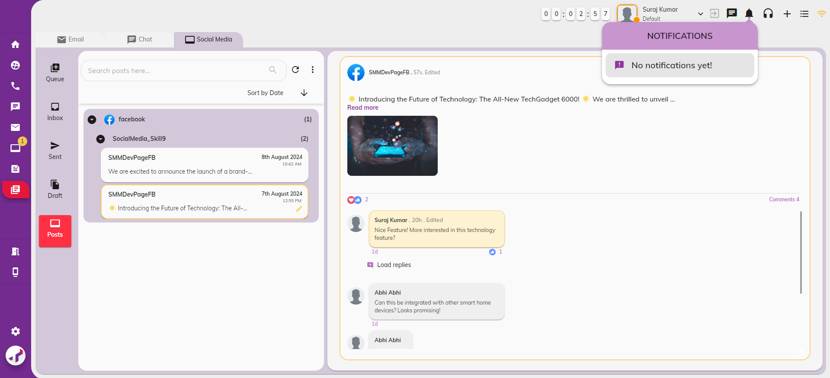

1. **Edit comments or replies on Social Media Platform**

When a comment or reply is edited on social media platform, the popup message – ‘*Comment has been edited!* ‘will be displayed for current interaction. A notification will also be sent to agents in AD.

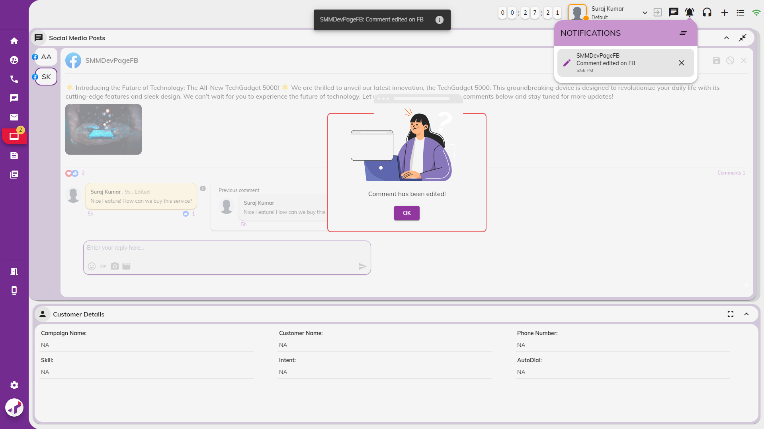

Next, edited customer comments will be updated in the Social Media Posts widget within the Social Media Interaction tab, marked with an "Edited" icon. Clicking the ‘i’ icon will display the most recent version of the comment or reply that was last edited. This information will appear only once and will disappear when you move to other interactions.

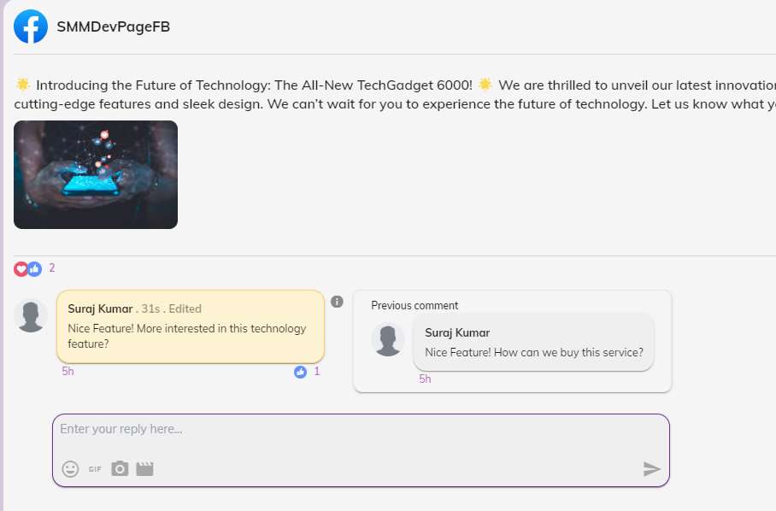

1. **Delete Posts on Social Media Platform**

When a post is deleted on social media platform, the popup message – ‘*Post has been deleted! This interaction will be closed*. ‘will be displayed for current interaction. A notification will also be sent to agents in AD. On clicking ‘Ok’ button, interaction will be closed.

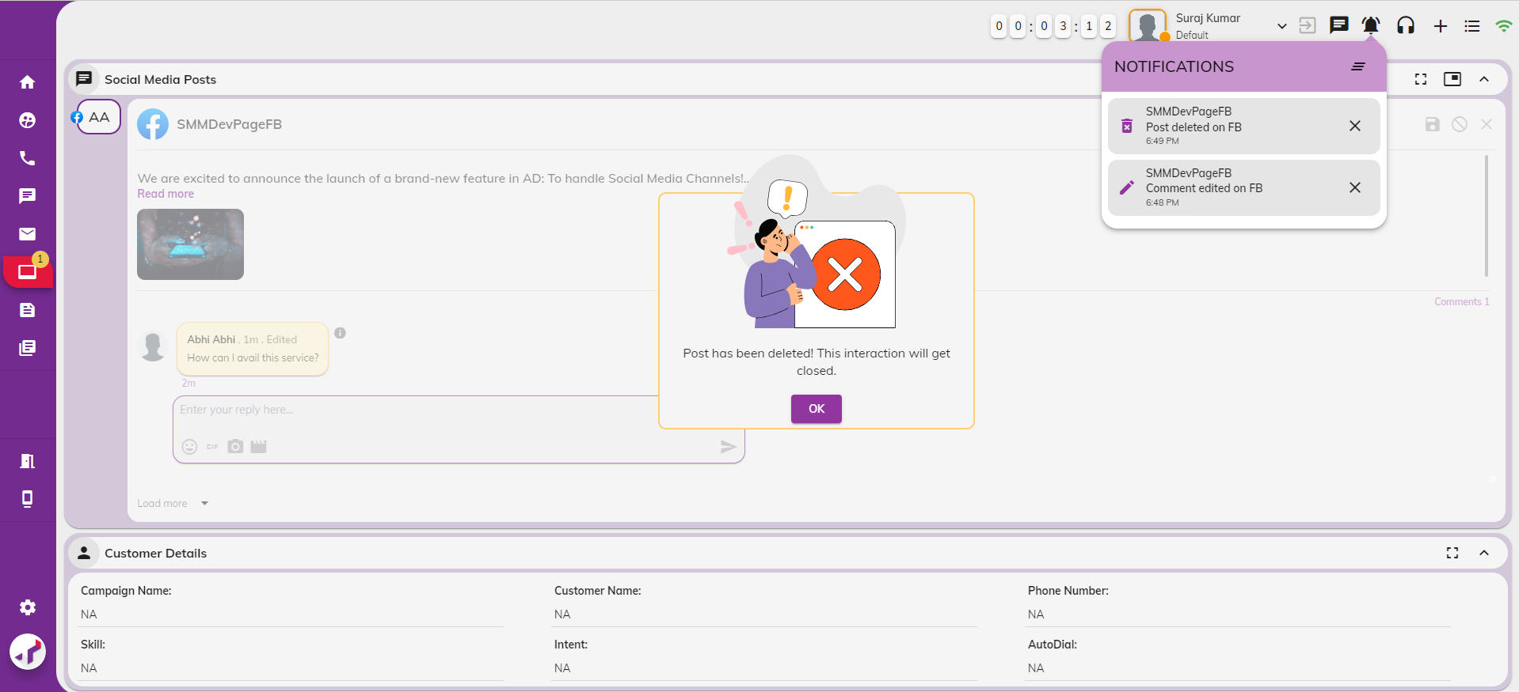

Clicking the notification will take agents to the Posts section of the Workbench, where the currently deleted post will be highlighted and displayed. Posts and comments will remain in the Workbench, but a Deleted Icon will appear for the post across all sections (Queue, Inbox, Sent, Drafts, Posts). Actions such as Transfer, Pull, and Close will be disabled for these posts.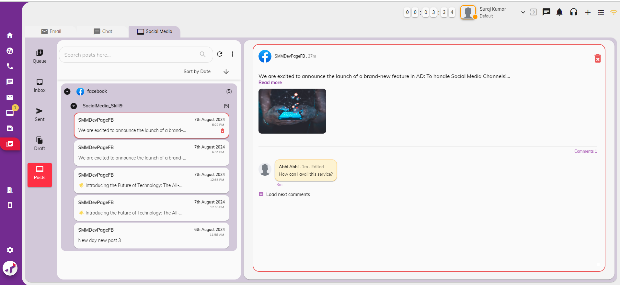

1. **Delete comment or replies on Social Media Platform**

When a post comments/replies are deleted on social media platform, the popup message – ‘*Comment has been deleted! This interaction will be closed*. ‘will be displayed for current interaction. A notification will also be sent to agents in AD. On clicking ‘Ok’ button, interaction will be closed.

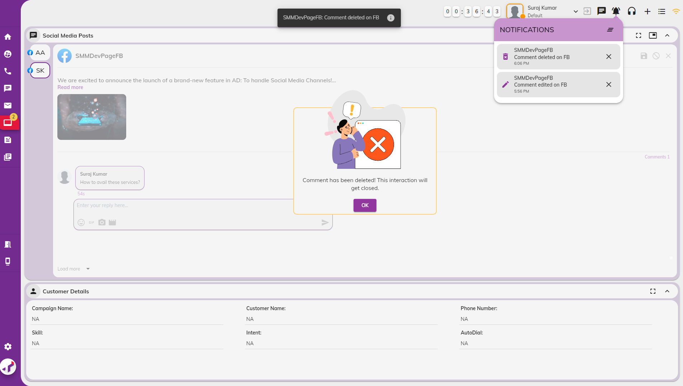

licking the notification will direct agents to the Inbox section of the Workbench, where the currently deleted comment or reply will be highlighted and displayed. Comments will not be removed from the Workbench. A Deleted Icon will appear for the comment across all sections (Queue, Inbox, Sent, Drafts, Posts) in the Workbench. Actions such as Transfer, Pull, and Close will be disabled for these comments.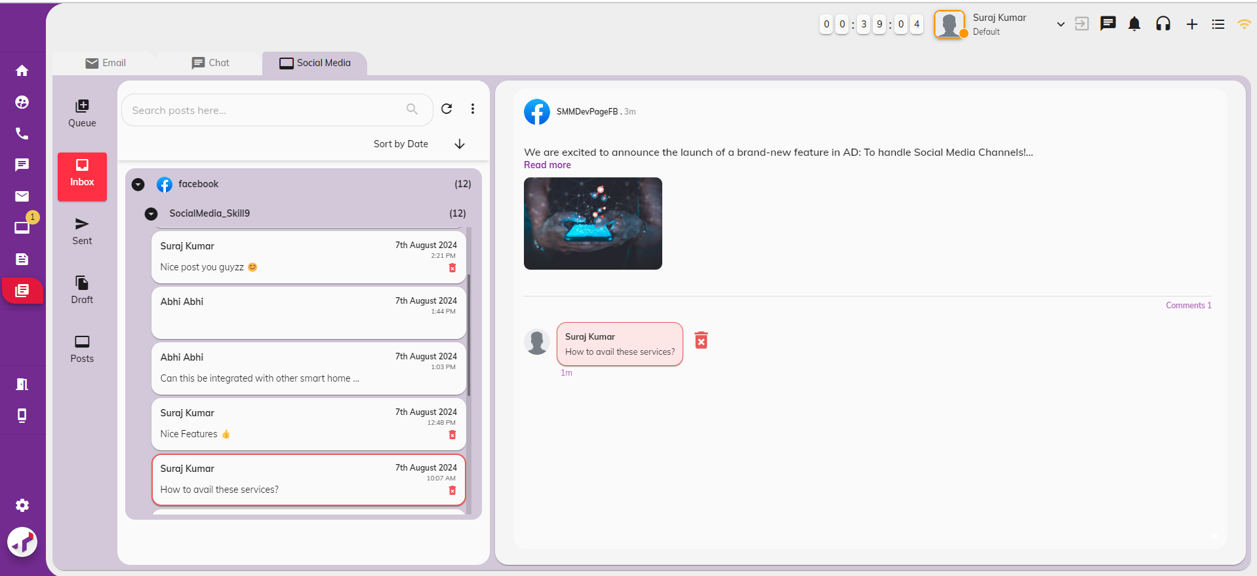

## Setting Reminders

On some days, you may have to check with your customers if the issue they have had has been resolved. And, on other days, you may require additional information from the customer to troubleshoot a problem, and your customers might ask you to reach out to them at a specific time. To handle such scenarios, TMAC supports creating reminders that enable you to perform your job efficiently.

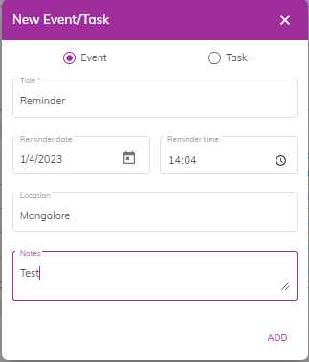

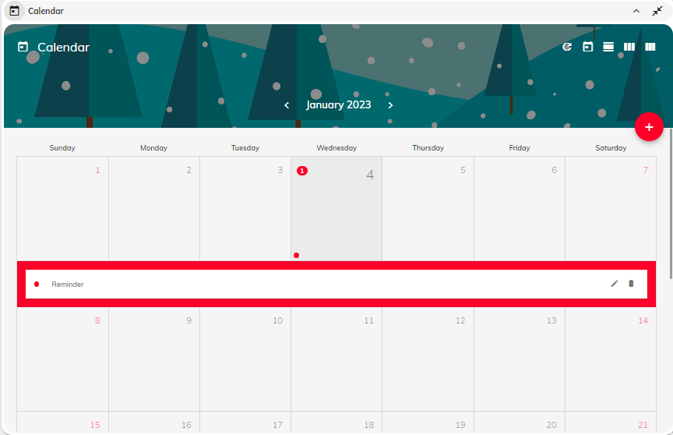

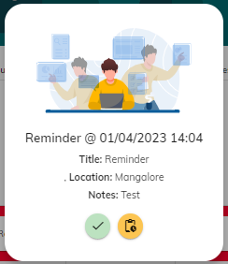

TMAC also supports creating task reminders where the system automatically performs the task at a specified time. For example, you can set a task reminder to change your status to **Break** at 3 PM on July 4th, 2021, or you can set a task reminder to launch an online meeting at 6 PM on July 6th, 2021. At the designated time, depending on the action configured, the system automatically performs the task (change status to break or launch an online meeting)

## Change AD Display Settings

Click  to modify TMAC display settings such as:

* + - Color Themes
    - Web fonts
    - Layout Styles
    - Navigation bar settings
    - Toolbar settings
    - Widget display settings

## Logging Out of TMAC

To log out of TMAC, do the following:

* Choose **Logout** from the status drop-down.
* Click  . Click **Confirm.**

You are now logged out of TMAC. The login page is displayed.

## View Notifications

Click  to view notifications.

## View Quick Settings

Click to  view the quick settings page. You can toggle ON/OFF browser notifications, notification sound.

## View App information

Click to view app information such as:

* Agent Desktop Name
* TMAC Server Name
* Event Mode
* Proxy URL
* SignalR URL

## Create Event/Task Reminders

Click  on the calendar widget to create event/task reminders.

## Setting Event Reminders

Event reminders are useful to remind you of any action that you must complete such as emailing a customer, attending a training session, troubleshooting a technical problem, etc at a specific day and time.

To set event reminders, do the following:

* Click  displayed on the calendar.
* Enter **event title**.
* Set the **date** from the calendar
* Set the **time** for the event.
* Enter **location**.
* Enter any **additional notes**.
* Click **Add**. The reminder is created, and it is displayed on the calendar (as a red bar).

**Note:** You can **edit** the reminder by clicking the edit icon on the red bar before the expiry of the reminder date/time. You can also **delete** the reminder by clicking the delete icon.

At the configured date and time, a pop-up window appears to remind you of the event. You can

either click to accept the reminder or click the snooze button to set an interval to bring back the reminder.

## Setting Task Reminders

Task reminders are useful to automate tasks such as changing status, launching online meeting at a specific day and time.

To set task reminders, do the following:

* Click  displayed on the calendar
* Choose **Tasks**.
* Select the task from the drop-down.
* If you choose **Call Customer,** then enter the number of the customer you want to call.
* If you choose the **Change Status** task, then select the status you want to change to from the Select Status drop-down.
* If you choose **Meeting** task, then enter the meeting link.
* Set the **date** from the calendar
* Set the **time** for the task reminder.
* Enter **location**.
* Enter any **additional notes**.
* Click **Add**. The reminder is created, and it is displayed on the calendar (as a red bar).

**Note:** You can **edit** the reminder by clicking the edit icon on the red bar before the expiry of the reminder date/time. You can also **delete** the reminder by clicking the delete icon.

At the configured date and time, a pop-up window appears to remind you of the task reminder. You can either click to accept the reminder or click the snooze button to set an interval to bring back the reminder. On accepting Call Customer task reminder, your status is changed to **On Call** and a call is made to the customer. On accepting the **Change Status** task reminder, your status is automatically changed by the system. On accepting the **Meeting** task reminder, an online meeting is launched by the system.

# **Glossary**

|  |  |
| --- | --- |
| **Term or Acronym** | **Definition or Description** |
| **OCM** | Omni Channel Management |
| **TMAC** | Tetherfi Multimedia Agent Client |
| **LAN** | Local Area Network |
| **CIF** | Customer Identifier |
| **CIQ** | Customer Interactions in Queue |
| **UI** | User Interface |
| **LANID** | Domain handle for a user (integrated with LDAP/AD) |
| **Omnichannel** | An omnichannel enables the agents to seamlessly switch between channels and provide a 360- degree view of the entire customer journey. The agents can effortlessly follow the customer conversations across different channels without being siloed into one channel.  For example, in TMAC the agent can begin a chat  with the customer and then roll that chat into  a video co-browse session or a voice call thereby providing a highly personalized experience to the customer. This kind of seamless interaction across technologies is the key to great omnichannel experiences. |
| **Contact center** | A central point from which customer interactions across various channels are managed. The primary purpose is to provide customers with efficient and effective technical support, customer service, and sales assistance. |
|  | Average Handle Time (AHT) is a customer service metric that measures the average amount of time needed to resolve a support or service request. This includes any time spent on holds, delays, or follow-up actions to fulfil the customer’s needs. It is a crucial KPI for contact centers. AHT is commonly used to assess the efficiency of an agent and the customer service organization as a whole. To calculate AHT, use the following formula:  AHT = (Talk Time + Hold Time + Follow Up Time)/Total number of calls  The average handle times of different contact centres vary depending on the company’s approach to customer experience and the product/service that they provide. Typically an efficient contact centre aims to  • Minimize hold times  • Optimize talk times  • Increase the number of calls handled  • Improve customer satisfaction  A lower AHT does not necessarily mean that the contact centre is doing well. It is very important that the agent does not hurry up the call to lower their AHT. The optimal AHT for a contact centre is a factor of decreased average handle time and increased customer satisfaction.  There are several ways to improve AHT such as:   * Effective Agent training * Build comprehensive knowledge management * Enable ongoing agent coaching * Optimize call routing |